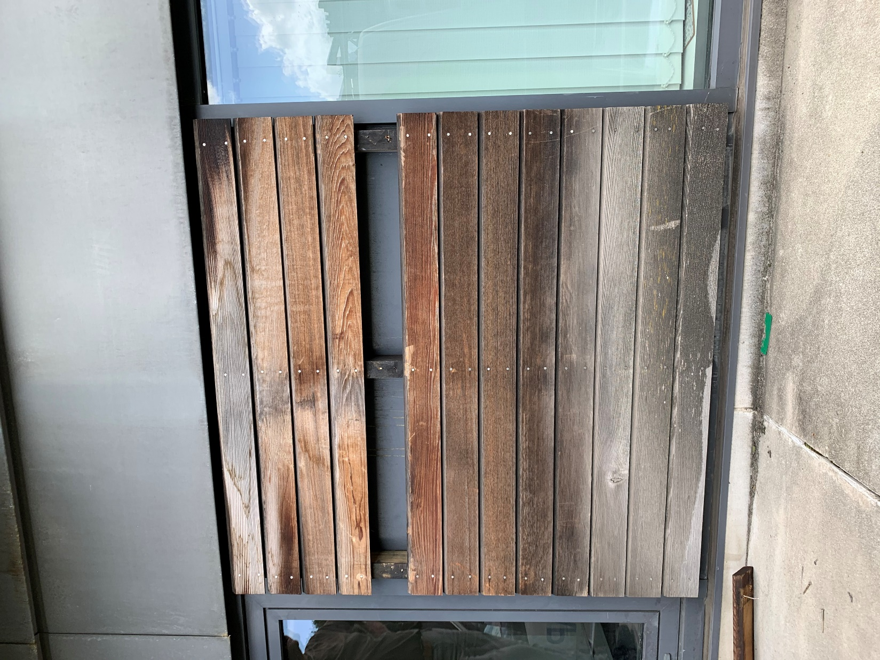
Photograph to illustrate appearance of existing timber cladding.

