

1-3 Commercial St. Knott Mill,
Manchester M15 4PZ
Waste Management Strategy

This waste management strategy has been prepared by In-Fill Design Ltd in support of the development proposals at 1-3 Commercial St, Knott Mill, Manchester.
The proposal is for seven seperate residential units to be developed on the site and the general layout is shown on the attached drawings
Manchester operate a system of Grey Bins for general rubbish, a Brown Bin for glass, cans and recyclable plastic and a Blue Bin for paper and card.
For this development a green bin is not required.
Refuse will be stored in wheeled containers in the garages of the properties and a purpose-built store for dwelling unit no. 7
Refuse will be removed from the garage by the residents and put on the street on the day of collection. The days for collection are available on the Manchester City Council website:
http://www.manchester.gov.uk/info/200084/bins_rubbish_and_recycling
The bins will be returned to the garages by the residents once they have been emptied.
The refuse vehicle will access Commercial St and Constance St and pick up refuse. There is sufficient space on Commercial St to accommodate a refuse vehicle whilst the collection is made. The vehicle will block the road on Constance St, however the road has very little traffic and the delay would only be temporary.
The Waste Management Strategy will be passed to anyone purchasing these properties.

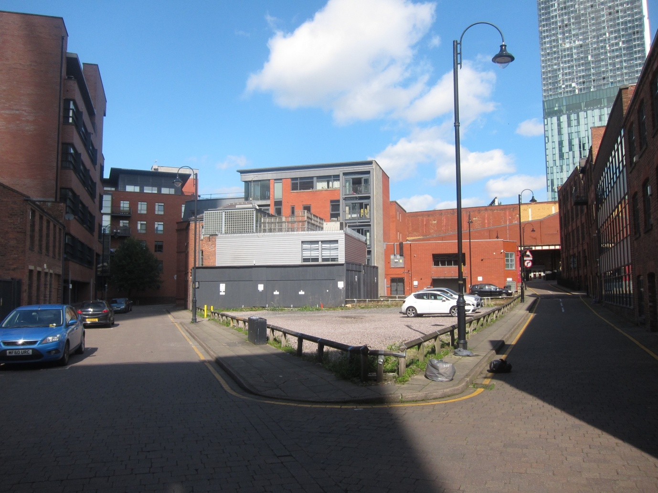

View of Commercial St (LHS) and Constance St (RHS) looking North

Ground Floor Plan Indicating Wheeled Bin Storage

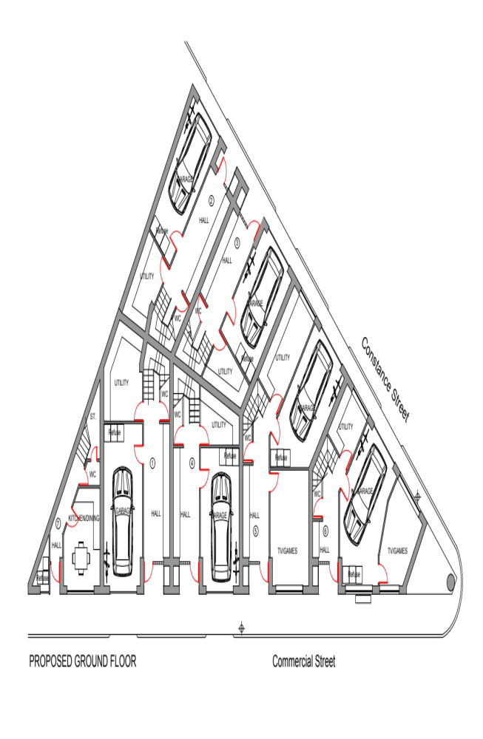

Floor Plans

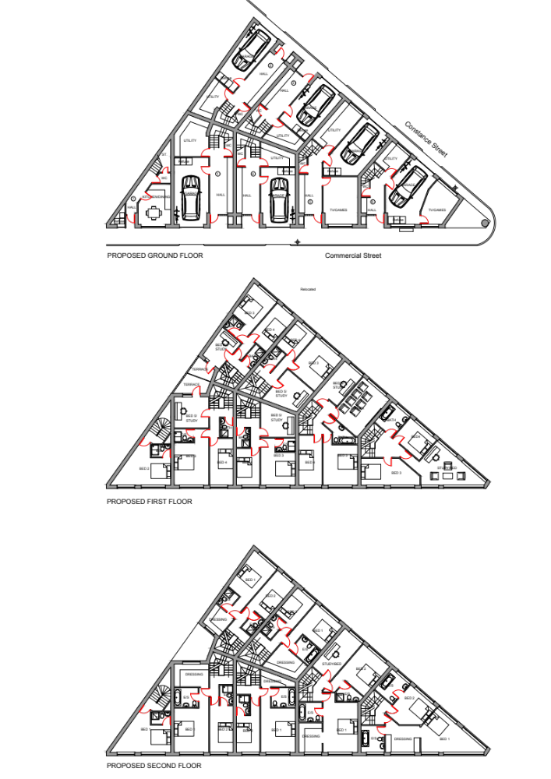

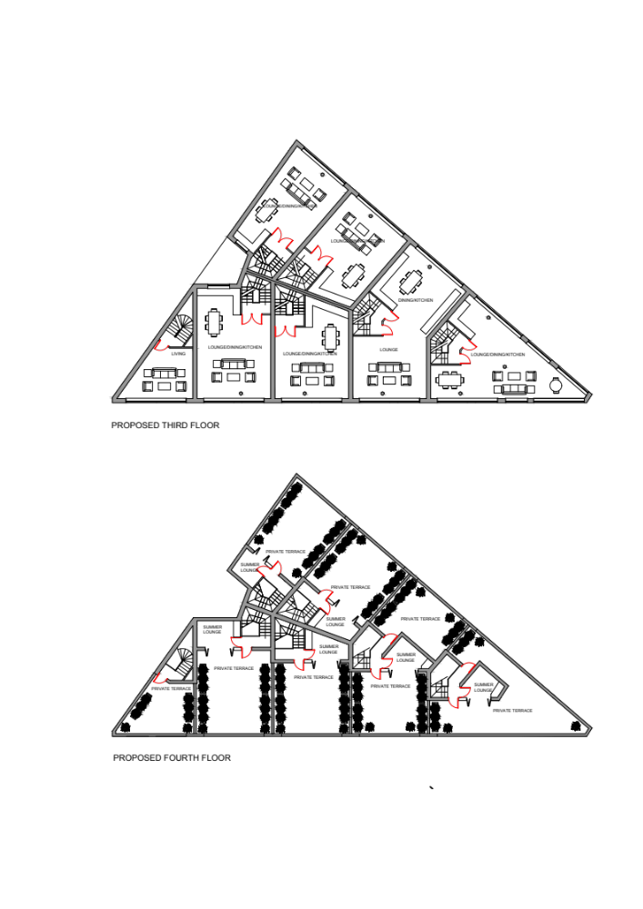

Extract from the completed waste management proforma
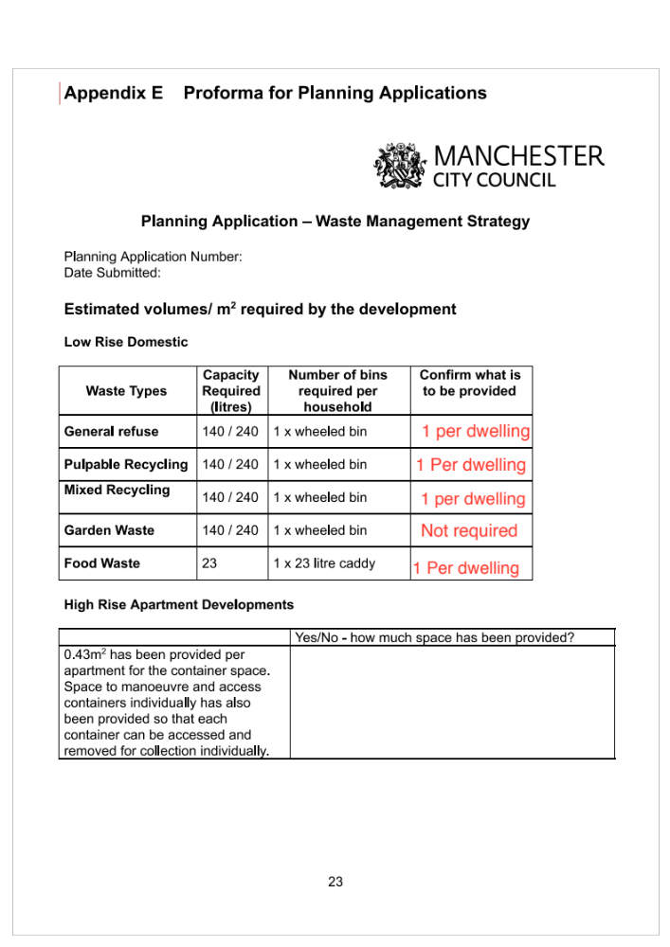

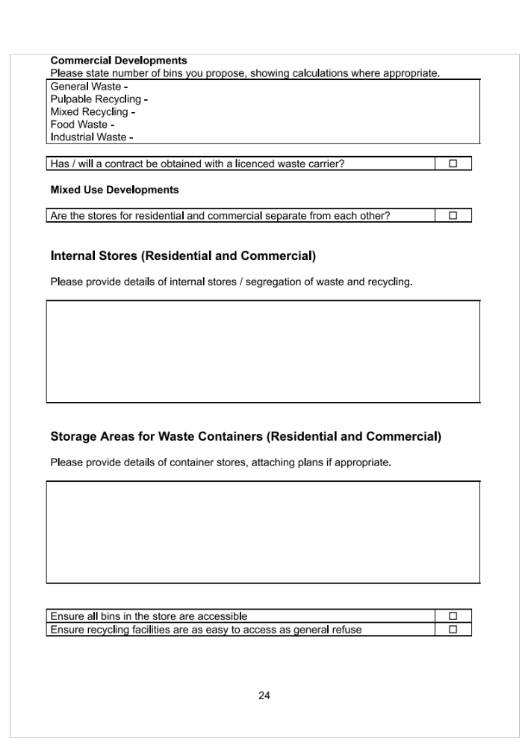

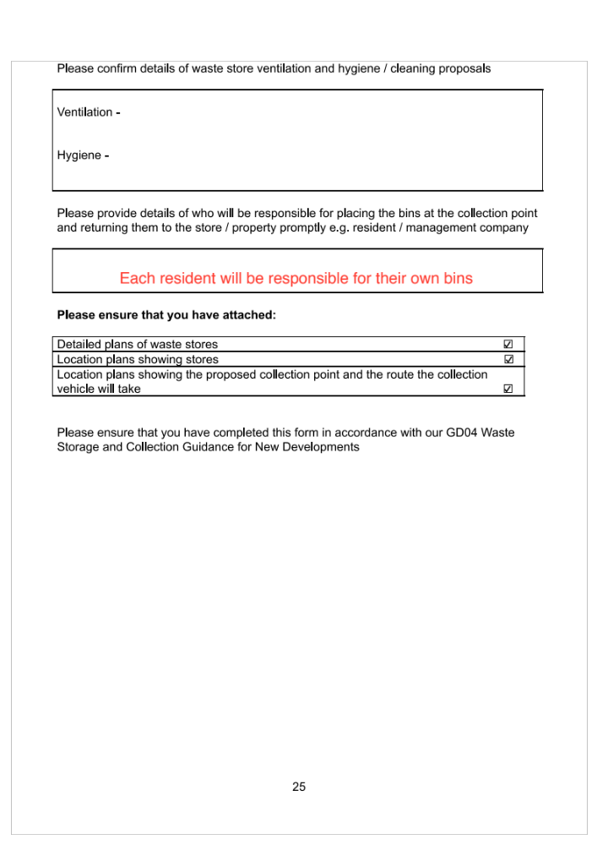
Hartland
13 Mayfield Road
Bramhall
Cheshire
SK7 1JU

