Manchester City Council Our Ref: PK/TH/SPC
Technical Support Team Your Ref:
Planning Date: 16th February. 2021
PO Box 532 Town Hall
Manchester
M60 2LA

Dear Sirs

RE: Application Number 128758/LO/2020
Proposal: Works associated with the use of the ground floor of the building.
Location: Ground Floor Chatham Mill, 8 Lower Ormond Street, Manchester M1 5QF

Further to your letter dated 29th January, in regard to the above application. I will refer to each of your points in turn.

Point 1) Revised drawings have now been uploaded to the planning portal.

Point 2) Revised drawings have now uploaded to the planning portal

Point 3) Scaled 'As Existing' and 'As Proposed' ceiling plans have now been uploaded to the planning portal.

Point 4) Revised elevations drawings have now been uploaded to the planning portal.

Point 5
- Details of how long the building has been vacant is dealt with at section 4 of the revised Heritage Statement that is now uploaded to the planning portal.

- Detail of other potential uses is dealt with at section 4 of the revised Design Statement. Whilst your preference for an open plan design has been considered the building size and configuration and most beneficial use does not lend itself to a fully open plan configuration. Moreover, I have referenced a recent listed building consent (122234/LO/2018) related to the first floor of the main Chatham Mill building in which a small individual office design, very similar to the application proposal was granted in 2019.

- With the above in mind the proposal is to meet the demand for individual studio type offices that would serve a variety of creative businesses. Whilst your comment is noted, the proposal provides for 11 individual offices of which two are to be located within the centre of the floor space. The original red brick walls, original iron columns, non-original historic doors and windows are proposed to be visible. Further, it is intended to remove all non-original and non-historic and therefore materials of no historic significance to reveal parts of the building that have been covered for many years. Thus, the proposed works has been designed to complement and be sympathetic to the buildings historic past and does provide views of the buildings original features and volume.

- With the above in mind the proposal is to meet the demand for individually lettable studio type offices that would serve a variety of creative businesses, as such adequate privacy is an expectation of potential tenants and if not provided would detract from the potential appeal of the units. Nonetheless, the proposal to install a mixture of both clear and opaque glass blocks considers both needs. As such this will provide both the necessary privacy for the offices and will also allow views of the original historic features and volume of the building.

Point 6) Scaled drawings of the building’s elevations have been uploaded to the planning portal. The external elevations to the application building are outside of the applicant’s demise and therefore no works in this respect are proposed., other than to overhaul the original doors.

I trust the above provides the clarity that you require in considering the application.

Yours sincerely

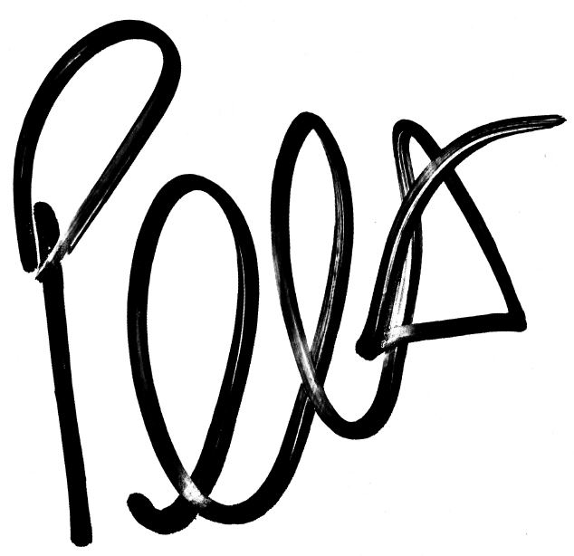

Peter Knight BSc (Hons) Building Surveying
Building Surveyor
For and on behalf of Scanlans
Office: 0161 236 8781
Mobile: 07384 252 138
Email: peter.knight@scanlans.com

