HERITAGE STATEMENT TO SUPPORT A PLANNING APPLICATION AND LISTED BUILDING CONSENT APPLICATION

FOR

CHATHAM MILL,
LOWER ORMOND STREET
MANCHESTER

CLIENT – DANIEL JONES
M-ONE STUDIOS LTD

DATE – OCTOBER 2020
Revised February 2021

application ref: 128758/FO/2020 & 128759/LO/2020

CONTENTS

1. INTRODUCTION
2 LOCATION AND DESCRIPTION
3 LISTING
4 HISTORY
5 CHARACTER AND SIGNIFICANCE
6 PROPOSALS AND IMPACT ON HERITAGE SIGNIFICANCE
7 MECHANICAL AND ELECTRICAL
8 CONCLUSION
9 POLICY

Appendices

- Annotated Photographic Record

To be read in connection with the following documents
- Drawings
  - T01.A1L - As Existing
  - T02.A3L - North Block - As Proposed
  - T04.A3L - Strip Out
  - T05.A1L – Elevations
  - T06.A3L Site Location Plan
  - T07.A3L Building Identification
  - T08.A3L - As proposed (2)
  - T09.A3L - Strip Out Sections
  - T10.A3L – As proposed Sections
  - T11.A3L – As existing Ceiling Plan
  - T12.A3L – As Proposed Ceiling Plan
  - T13.A3L – As proposed Ceiling Plan Sections
  - T14.A3L – Waste disposal plan
- 13102020 MATERIALS STATEMENT Chatham Mill Manchester (SPC10029)
- 13102020 DESIGN STATEMENT (v3) Chatham Mill Manchester SPC10029
- 13102020 PLANNING STATEMENT (v3) Chatham Mill Manchester SPC10029
- 13102020 WASTE STRATEGY Chatham Mill Manchester SPC10029
- xpelair-ventilation-guide

- INTRODUCTION

  - This Heritage Statement has been produced to accompany the Planning and Listed Building Applications for Chatham Mill, Manchester.

  - As described in the Design and Access Statement, the application is confined to the area within the Client’s ownership. The demise is limited to the ground floor of the north block.

  - This report only covers the areas stated. It does not act as a condition survey.

- LOCATION & DESCRIPTION

  - Chatham Mill is located on Chester Street, Lower Ormond Street and Lower Chatham Street, off Oxford Road in Manchester, to the south of the city centre (drawing reference T06.A1L).
  - Chatham Mill is owned by M-One Studios. Comprises a variety of buildings of varying ages and style. M ONE offer creative studio space for rent in the centre of Manchester and is based within main Chatham Mill building.

  - The application building is one building within Chatham Mill development, owned by M-One Studios. M ONE provides a creative environment for freelancers and small businesses to thrive and meet like-minded people.

  - The mill is six storeys with six main buildings and a variety of extensions and linking structures. The largest of the extension is the two-storey extension to the rear of the main Chester Street mill building, running approximately one third of the length of the mill block.

  - The main entrance to the former mill is on the long Chester Street block. Stairs lead through a double height, white painted surround which appears to be (at least in part), a later addition, dating from the 1920’s.

  - The building is red brick, architecturally plain and typically functional in form with regular rectangular windows with stone sills and a pitched slate roof. The rectangular windows to the main Chester Street elevation are timber framed, with nine lights in each. Two further buildings adjoin the main mill and run along Lower Chatham Street, rising to two and a half storeys at the further end.

  - Along Lower Ormond Street is a further four storey building. It is attached to the main building by way of a linking section in the form of a gated double height archway at street level. This arch gives access to the yard at the back of the mill. This four-storey block is smaller in scale with a number of standard sized pedestrian entrances on this elevation and smaller sash opening windows with four panes. Central to the block is a round headed door with circular window above.

  - There is a chimney in the courtyard facing corner, in the angle between the main mill and the Lower Chatham Street building. A former hoist is evident to the rear of the main block and there are three newer vertical access towers at various points along the main building.

  - Chatham Mill is one of a number of textile mills located in the Chorlton and Medlock area. It forms part of a group, the majority of which have been refurbished and converted to residential and mixed-use space in the last 20 years.

  - The application is limited to the ground floor of the north block located in the car park area behind the Chester Road building on the accompanying plans.

  - For ease of reference, the different parts of the site have been labelled throughout this document as follows: (Drawing Ref T06.A3L and T07.A3L).

A – Main Chester Street front block
B – North block [application subject]
C – Rear left hand side block with exposed roof structure. [application subject]
D – Lean to block with sloping roof.
E – Linking structure between blocks A & B.
F – Loading bay to the left-hand side of the main block A.

The application buildings are indicated buildings B and C in drawing reference T07.A1L.

- LISTING

  - The mill is Grade II listed, the Historic England listing text is included below:

  - SJ8397 CHESTER STREET 698-1/19/61 (South side) 11/03/88 Chatham Mill GV II

  - Cotton spinning mill, now used as warehousing etc 1820, with extension of 1823 along Lower Ormond Street. Brick with slate roof, which has clerestory windows. Original block is 6 storeyed, 17 bays, with site of internal engine house against gable wall to SW (round arched opening partially blocked and cut by C20 loading bay), with remains of chimney aligned with this to NW.

  - Taking in doors to all floors towards centre of rear elevation, reinforced with cast iron. Entrance leading to staircase in rusticated arch in NE corner, within archway to courtyard formed after extension of mill. Small rectangular windows with cambered brick heads in each bay, 4 storeyed 12 bay wing to Lower Ormond Street, with courtyard entry to left, and central doorway. Interior construction has timber floors carried on cast iron columns in original range and fire proof construction to 1823 wing, in which cast iron columns and beams carry transverse brick arches. Layout of mill, including position of taking in doors suggests possible origins as room and power mill. Included as a typical and coherent example of an early C19 mill, in which a single range has been extended to form an L-plan, itself a typical pattern of growth.

  - Listing NGR: SJ806897289

- HISTORY

  - A report on a survey of Chatham Mill by Manchester Regional Industry Archaeology Society was located in Manchester Library archives. It suggests the following timeline for the mill:

  - 1818 – Runcorn and Bellhouse listed as cotton spinners at Medlock New Mill, York Street. The south wing of the mill (Chester Street) block was completed.

  - 1819 – The Runcorn brothers, Richard and John, were listed as cotton spinners at Chester Street mill, Ormond Street.

  - 1823 – The Runcorn brothers completed the east wing to spin fine yarns.

  - 1824 – The plan of the mill taken from Swire’s map of Manchester shows the east wing along Ormond Street and the main block along Chester Street, with an extension to the rear

  - A further brief history can be found in Clark, 5, Chorlton Mills and their neighbours, Oxford University Press, 1978, “The last vacant lot on Chester Street was taken by the Runcorn Bros, second generation spinners whose father had died during their boyhood….. Their capital had helped David Bellhouse to start his mill. Now they set up for themselves…… The main building was completed in 1820 and still in use, is wooden floored, rather exceptionally for that date and place, but the long low extension along Lower Ormond Street, added in 1823, is basically fireproof in spite of some wooden additions. The ground floor of the mill is used as a grocer warehouse and has been much reinforced, the upper floors are occupied by garment workers and seem little changed from their original form except for partitions. There is an engine house, fireproof and smoke blackened, at the west end of the yard. The small block serves the purpose for which it was no doubt designed, as offices, with the arches neatly picked out in paint. Some of its iron work is rather fancy, as though it had been transferred from a railway station”.

  - As Manchester grew into a large industrial city in the nineteenth century, the area around Oxford Road was almost exclusively covered with the buildings engaged in the cotton trade in one form or another, alongside accommodation for those who worked in the mill and workshops. Even earlier, in 1794, there were already mills east of Oxford Street and the area continued to develop as a pocket of industrialisation. The housing area, known as Little Ireland, was notoriously poor and conditions appalled even contemporary commentators. Following demolition of the slum dwellings, the River Medlock was culverted in the mid nineteenth century, apparently partially under the Chatham Mill.

  - Several references found in archival evidence class the mill’s business as ‘cotton waste’. This sub trade of the cotton industry was not uncommon and produced items of a lower quality for practical domestic and commercial uses. A contemporary advert describes the type of product from Chatham Mill.

  - “Cotton Waste Manfrs. Adams & Co Limited (manufacturers of engine cleaning waste sponge cloths, lamp and candle wicks, bunting, flags, mops, scouring flannel, twines, wad-ding, cotton wools, cotton and woollen flock, lubricating pads & home, foreign and colonial government and railways stores contractors), Chatham Mills, Manchester”.

  - Historic maps give an indication of the chronological development of Chatham Mill and though precise dates of the many and varied additions and alterations are uncertain, it is possible to outline a likely timeframe of the main blocks. It should be noted that the mill is occasionally referred to as “Runcorn Mill”. This is reference to the original owners, rather than any geographical link.

  - From the images previous and archive research, it is concluded that the main block (A) dates from around 1818 and the Lower Ormond Street block from slightly later, c. 1823. The square rear [application subject] block (B) is present on the 1894 map, though not on the 1845 one, so was originally constructed between these dates. The rear main block extension and link bridge (D & E) are later additions.

  - The rear left hand side [application subject] block (C) is present on the 1905 plan; therefore, it can be dated from between 1894 and 1905.

  - The loading bay (F) has undergone changes in its form from the outside in the latter half of the twentieth century, presumably to accommodate access for modern delivery vehicles.

  - There have been a number of changes over the lifetime of the mill, including the addition of vertical circulation towers to the rear of the main block and the rebuilding in part of the rear blocks, particularly the square block building (B). This structure is subject to the application is a non-original and inappropriate roof and evidence of rebuilding of the brickwork.

  - The application subject building, The north block building (B), became vacant at the end of September 2019.

  - Since the 1970s it has served a variety of uses. It was used to slaughter and store meat, hence the white tiles on wall & remnants compressed air pipes for cutting machinery. This was for Lynn foods, who were the previous owners of mill prior to the current owners father (deceased). This use ended in the early 1970’s. The current owners father then used the building as a sheet metal workshop & office. This ended in around 1982.

  - Since 1982 it has been partially used for architectural document storage unit and partially for the Chatham Mill owners office until 2007 before it was relocated in to the main mill buildings. The most recent use of the application building was as a maintenance workshop and storage area for the on-site maintenance team.

- CHARACTER & SIGNIFICANCE

  - Chatham Mill is Grade II listed and is therefore afforded a degree of statutory protection as a designed heritage asset. Historic England documentation outlines the importance of the assessment of significance of assets to determine the nature of the significance, the extent of that significance and the level of the significance.

  - The HE document, Conservation Principles outlines four types of heritage value: aesthetic, communal, historic and evidential. Chatham Mill has evidential value as an example of early nineteenth century industrial architecture, particularly related to the cotton industry. It stands as evidence to past human activity. However, in reference specifically to the applicant’s interest in the building, this value has been compromised by the inappropriate additions and the prolonged lack of maintenance which has resulted in a deterioration of the buildings fabric.

  - The building is of some historic value. It is one of a group of mills in the All Saints area, a number which remain and some of which have been demolished. The remaining properties have almost all been converted to residential or commercial use; Chatham Mill is one of the few yet to be comprehensively redeveloped. The grouping of these mills is evidence of the nature of distinctive industrial development in the immediate locality, in Manchester, in the North West and in Great Britain. Chatham Mill’s place within the wider group is therefore particularly significant.

  - The aesthetic value of Chatham Mill is mainly in its contribution to the wider industrial setting and its place as a piece of that specific urban landscape. The design of the building itself is not of high quality or of particularly architectural significance and has been somewhat diluted by the ongoing piecemeal changes over the evolution of the space. Internally the aesthetic significance is based in the basic structural elements of the building, which would typically be exposed in a mill of this kind. Unsympathetic later coverings, partitions and additions continue to have a negative impact on the character and heritage significance of the site.

  - Chatham Mill has a social/communal value as part of the cotton industry in Manchester and the important role that played in the lives of the workers and the country as a whole. That value is no longer first hand as the mill has long ceased to be used in its original function and is more associational, as part of the character of the area and the links with the cotton industry of the city.

  - The evidential significance of the mill has been degraded by the physical changes, partial loss and degradation of the interior spaces and inappropriate external changes to the rear of the site. The original use is still readable however, and the phased development of the mill remains evident through the presence of different blocks and extensions.

  - The plan form is still evident, though it has been subject to a number of subdivisions. The original building materials and structure are mostly remaining, with some low quality additions and changes, particularly in the lean-to rear extension and the alterations to the exterior of [application subject] Block C. The spatial characteristics and evidence of former use are most evident in [application subject] Buildings B & C.

  - Building A is considered to be of highest heritage significance, being the oldest part of the site and a more complete example of early nineteenth century mill space. The exposed structural elements (cast iron columns and surrounding reinforcements, beams and timber floor) and the spatial characteristics are all considered significant. The sliding door and relationship with the loading bay significant.

  - Building B, which forms the building related to these application proposals, is of medium significance. It existed on the site since the mid-late nineteenth century. The fire escape stair and first floor office have changed the original spatial characteristics of the space.

  - The windows on the outer North, East and South walls have been replaced with reproductions which lack the detail of originals (such as tilting central openers found in the main building). Whilst the columns, floor and some of the rear windows appear to be of an older date, there is evidence of substantial rebuilding including areas of non-matching smooth faced red brick, to the exterior walls.

  - The original slate roof has been partially replaced with a heavy modern tile which has resulted in the loss of original historic fabric but is considered appropriate in the context of the building, historically, aesthetically and architecturally.

  - Building C is of medium/high significance. Whilst it is from a later date, it is a good example of column free space design with the original roof structure remaining and part of the belt drive still visible. It has undergone some changes to the rear wall and the condition of the roof and floors is poor.

  - Building D is of medium/low significance. It holds some evidential value as evolution of the site, estimated to date from the second half of the twentieth century. It is not of a high quality in either design or build form.

  - The strangely configured separation of the upper and lower floors along with the painted out windows has compromised these areas intended context, making it difficult to read as a component part of the building. The whole has been poorly maintained and as a result, there has been water damage, particularly to the floor. Overall, it is considered to be of medium/low contributory value to the character and significance of the building.

  - Building E is the bridge/link. This is considered to be of low heritage value. It is of poor quality, using low grade materials and is in a poor condition. Its value is limited to its plan form; a bridge link typical of mill premises but there is no architectural value to the existing structure.

  - Building F is the loading bay. The outer extending part appears to have been added at a later date and is of low heritage value. The internal space is of higher value with medal edge curbing visible (although the central ‘road’ has been infilled). There is a large opening to the first floor of Block A with an industrial sliding door. This is of some evidential value. The value of the area is primarily based on its spatial characteristics and its role as a component part of the wider site rather than any particularly significant elements.

  - There is limited evidence of the original function of the building from the interior fittings, but the structural elements are characteristic of a mill of this period and together with the linked plan form of the various spaces, are considered the most significant features of the site.

- PROPOSALS AND IMPACT ON HERITAGE SIGNIFICANCE

  - The different structural blocks have all suffered to some extent from lack of maintenance and repair and unsuitable interventions. However, as a whole, they illustrate the development of Chatham Mill and are considered to have some significance as evidence of evolution of the site. It is proposed to retain them within the application.

Proposed work to the ground floor of buildings B and C only

  - The proposals to this area which have an impact on the heritage value of the Blocks B and C are listed below:

  - Historic Non-original Windows: As the majority of these are outside of the demise of the client, proposed change is not possible. Glass will be repaired where necessary and all existing openers made functional. This is an enhancement to the existing situation and is of no harm to the heritage value of the building.

  - Removal of existing non-original, non-historic partitions: These are not of historic or architectural value. They are in poor condition and of a low quality. Their removal is considered beneficial to the space and will restore more original proportions and dimensions. (Note 3 Drawing T04.A1L and T09.A3L)

  - Non-original, non-historic ceilings: (refer to drawing T04.A3L, T11.A3L and T12.A3L) ply and Asbestos Containing Material (ACM) linings are present to the ceilings in some areas. They are non-original, of low quality and with no historic or design value. It is proposed to remove all linings in all places. (Note 6 Drawing T04.A1L) In their place two layers of 30 minute fire rated plaster board sheets will be fixed to the underside of the joists to form the ceiling. This is in compliance with the Regulatory Reform (Fire Safety) Order 2005. The columns will be cladded in 30 minute fire rated sheet material, there will be a shadow gap to ensure the structural columns are exposed in their fuller height and highlight them as an original feature.

  - The boarding will be manufactured to a standard that achieves the fire rating in accordance with the current BS EN 13501-1 classification, which currently does not exist.

  - The replacement with two slimmer layers of plaster board and creation of a shadow gap around columns is considered an appropriate response to create the required level of fire protection and maintain maximum exposure of the structural features.(refer to drawings T10.A3L, T11.A3L and T12.A3L)

  - Original Walls: Part of the internal and perimeter walls have a ceramic tiled finish. This is not considered to be original but has been present for some time. They will not be removed by the proposal. They will be cleaned and where necessary protected by internal timber frame lining. (Note 2 Drawing T04.A1L, T10.A3L )

  - Part of an original internal cross wall is to be removed to create an access door to serve the arrangement. (refer to drawing T09.A3L, T10.A3L),

  - The walls forming strong room/bank vaults type units will be retained and the space reconfigured to provide the toilet facilities to service the office accommodation.

  - Toilets: There are no existing toilets/kitchen. The proposal is to create communal facilities for male and female wc’s within the existing bank vault/strong rooms located to the rear area space. This will have no impact on the significance of the asset and is considered an enhancement to the space. Hot water, Cold water and waste will be connected to existing utilities services and drainage that currently serve the existing WC facilities. Final connection point to established during the work program

  - Offices: The proposal is to create a series of self-contained individually lettable cellular office spaces with columns. There is a need for a degree of separation within the space to:

  - To allow access corridors,
  - To comply with The Building Regulations Approved Document B (fire safety) volume 2: Buildings other than dwellings, 2019 edition incorporating 2020 amendments.

  - To comply with the necessary fire compartmentation Regulatory Reform (Fire Safety) Order 2005,

  - To facilitate Social distancing to help reduce the spread of coronavirus (COVID-19) thus to make the individual workplaces COVID-secure in accordance with current HSE guidance (https://www.hse.gov.uk/coronavirus/index.htm)

  - The partitions are to be full height and glazed to allow the passage of natural light and to retain views of the original building fabric. The partitions are to be a mixture slim opaque and transparent glass block partition (refer to document 13102020 Materials Statement within this application suite).

  - Window openings have been created on the internal wall to echo those on the external wall. This allows light and visual permeability to be retained from both sides. The impact of this new corridor is considered to be low. It creates minimal subdivision, and the effect is mitigated by the creation of glazed internal window forms and the glass partition section.

  - The application subject building’s roofs are outside of the design scope and are unaffected by the proposal and therefore it is not referenced and is not included within this application.

- MECHANICAL AND ELECTRICAL

  - A sprinkler system that serves the entire Mill including Blocks B and C is currently installed and is fully operational. It is not intended to remove the sprinkler system; however, the proposed reconfiguration may require minor alteration.

  - Throughout the building there will be a need to install sustainable heating. Comfort cooling will be achieved utilising the building fabric. It is not intended to install a mechanical cooling system. Natural ventilation will be provided by the numerous openable windows. Mechanical Ventilation to the WC block will be by means of a multipoint ducted “silent” extract system such as or comparable to the Xpelair Xplus 2 range. The Xplus 2 is a high performing central extract system designed to continuously extract stale, moist air from domestic kitchens, bathrooms and commercial wet rooms. (Refer to Xpelair Product Literature). The advertised sound pressure level of the product is 47dB@3m. This corresponds to the generally acceptable sound emitted from a quiet street in a residential area.

  - There will be no suspended ceilings or raised floors, ensuring the historic fabric is retained and revealed.

  - Services will be exposed and suspended from ceiling level. This is an approach approved at many listed buildings and is considered wholly appropriate in this location.

  - An electric boiler will provide hot water to the wet radiator heating system which will be necessary where the building fabric does not perform adequately. It is proposed to ensure the offices can offer the level of accommodation desired by tenants. There are a limited number of interventions required to accommodate this. The system is yet to be designed. The pipes will be carried from the meter/plant room in the floor layout, in galvanised trays at ceiling level. Routes will be designed to cause limited disturbance to original fabric and run along the perimeter of spaces and next to existing beams to limit visual impact. As a result, fixings are limited and views across the block will remain uncluttered by pipes.

  - Sustainable LED Lighting is to be suspended, with limited penetrations through historic fabric. It is designed to run in line with the existing beams wherever possible and avoid the creation of new grid forms. The resulting level of harm is considered low and justified to create viable lettable space and in preference to the significant intervention of raised floors.

- CONCLUSION

  - Chatham Mill is listed at Grade II. This status affords it a level of statutory protection to ensure that its architectural and heritage value are protected.

  - The proposals in this application have an added level of complexity, given the split ownership of the building and the unusual constraints of the demise. Ideally the building would be subject to a comprehensive refurbishment scheme, however this is not possible at the current time.

  - The design proposals are a response to the needs of the heritage asset and the limitations of the situation. All aspects of the proposal are considered to represent less than significant harm to the building and offer a much-needed long term viable re-use for this part of the building.

  - It is considered that the proposals represent the optimum solution for re-use, whilst affording protection to the significant features and character of the listed building.

  - Importantly, they are considered to successfully address the issues of long-term sustainability without compromising any future refurbishment plans for the wider building.

- POLICY

  - NPPF S. 54 requires a demonstration of sustainability for historic buildings. These proposals are a conservation led response to ensure the heritage asset can be put back into sustainable use and therefore meet this policy requirement.

  - NPPF paragraph184 states that uses for historic buildings should be consistent with their conservation and the importance of ensuring that the significance of the asset is sustained and enhanced.

  - The proposals provide an appropriate and viable economic end use, whilst enhancing remaining architectural and historical features of significance through restoring spatial character, undertaking repairs, and removing harmful interventions.

  - Remaining historic features will be repaired and exposed. Where new interventions are required, these are seen as a suitable response to the listed asset and will be readily identifiable as a further layer of adaptation to the building.

  - The changes do not represent significant harm and in areas where there is a level of impact, this is considered to have been mitigated and the resulting application will have the benefit of a conservation led approach to re-use. The proposals are therefore in accord with NPPF paragraph 184.

  - The level of harm is considered to be less than significant in all aspects of the proposals. Where there is a minimal degree of harm to the existing or historic fabric, this is included to be greatly outweighed by the benefits of securing a much-needed sustainable future for the asset and the additional public benefits of enhancing the condition of the building. In this respect, the plans accord entirely with NPPF paragraphs 196 and 197.

  - The proposals are also in accord with Manchester City Council Policy, EN3, which states development should preserve or enhance the historic environment and that re-use will be encouraged where it is considered to be consistent with the significance of the heritage asset.

Appendix A
PHOTOGRAPHIC SCHEDULE

Chatham Mill, Lower Ormond Street. M1 5AY. General images (128758/F0/2020 & 128759/FO/2020
A1 | 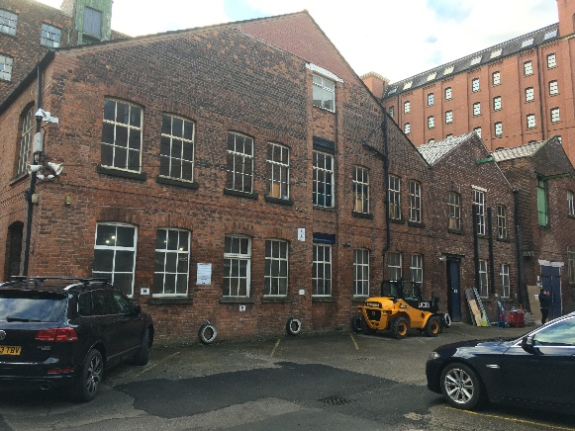 | General View of North Elevation of the application subject building. Ground floor windows and doors to be retained and overhauled.
A2 | 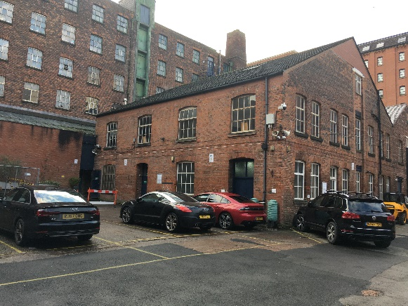 | General view of East Elevation of the application subject building. Ground floor windows and doors to be retained and overhauled.  Note the application relates to ground floor alterations only. The roof is unaffected by the proposed works and is not included within this application
A3 | 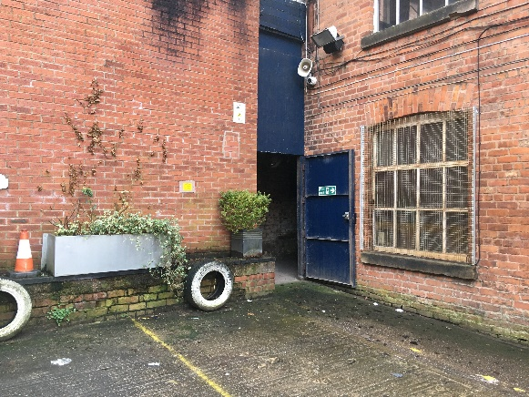 | Steel galvanised grid to be carefully removed and discarded.
A4 | 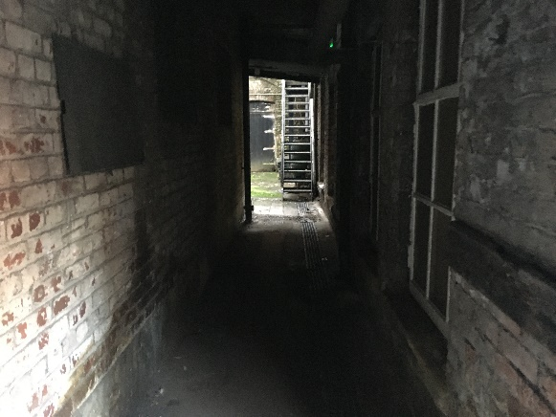 | General view of South Elevation of the application subject building. Ground floor windows and doors to be retained and overhauled.
A5 | 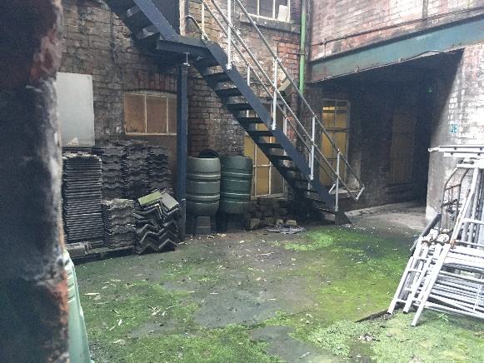 | General view of South Elevation of the application subject building. Ground floor windows and doors to be retained and overhauled.
A6 | 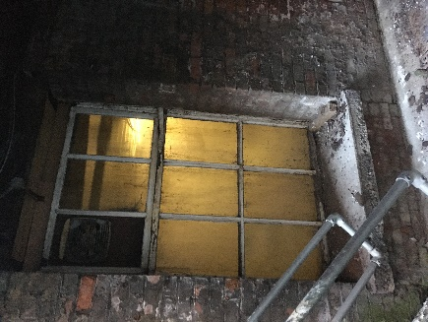 | View of typical window to South elevation. To be retained and overhauled.
A7 | 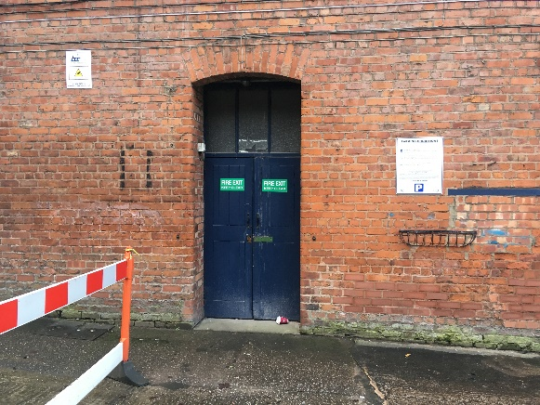 | View of Door (D3) level access door to be converted to main entrance to ground floor of the application building only.
A8 | 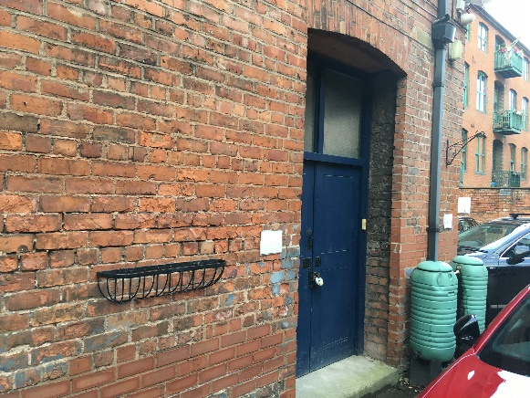 | View of Door (D2) to be retained and overhauled
A9 | 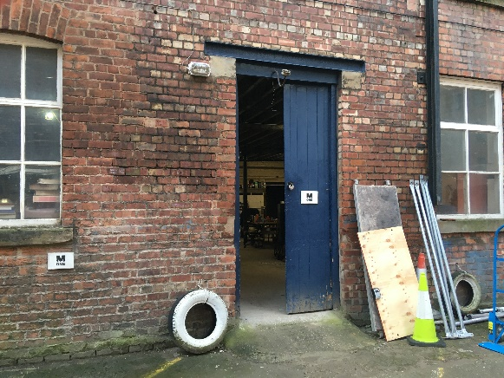 | View of Door (D1) to be retained and overhauled
A10 | 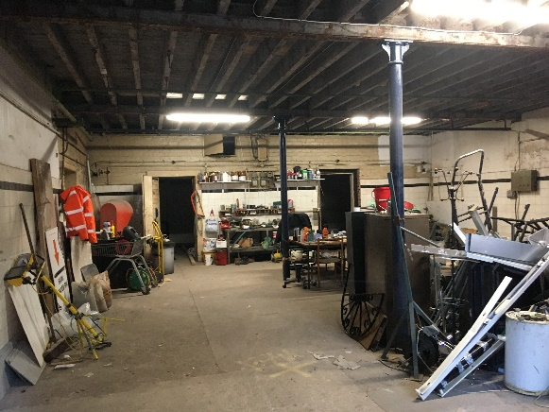 | General internal view of the ground floor of application subject building C. Note level concrete floor slab to be retained and patch repaired as necessary.  Original structural columns to be retained and carefully cladded for fire protection.
A11 | 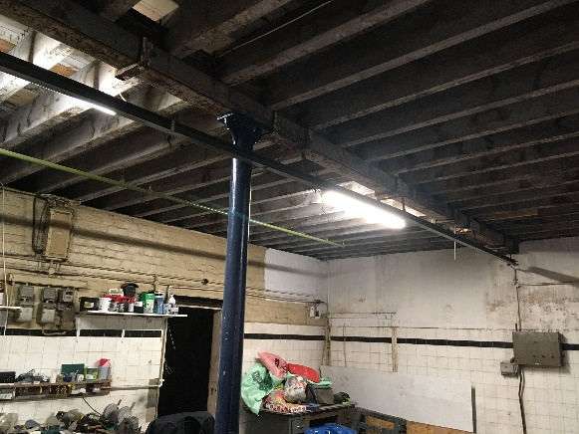 | General internal view of structural column arrangement at application subject building C
A12 | 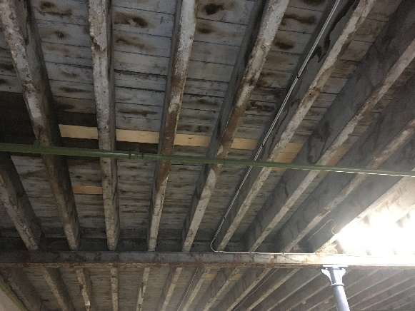 | General internal view of underside of first floor(ceiling) to application subject building C. Proposal to install fire rated board to the underside.  Note, existing sprinkler system is to be retained and decorated
A13 i | 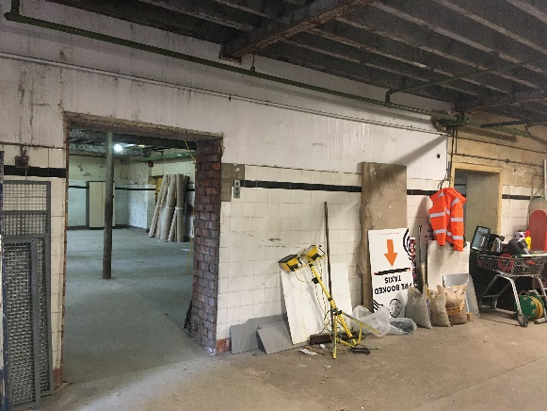 | General view of dividing structural wall between building B and C. Proposal to enlarge both openings. Retain remaining ceramic tiles and protect with board lining.
A13ii | 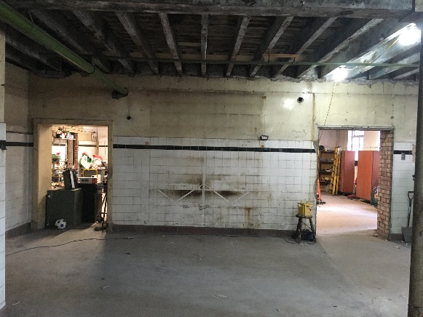
A14 | 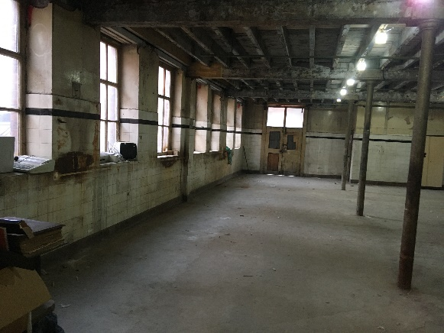 | General view of internal North elevation wall (drawing T09 Section A-A). Proposal to strip back non-original plaster above tiles to reveal original brick work. Clean and retain ceramic tiles. Original steel columns to be retained and decorated. Original door (D2) to be retained and overhauled.
A15 | 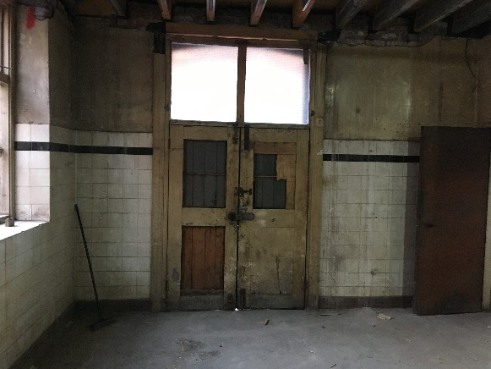 | Close up internal view of door D2, to be retained and overhauled.
A16 | 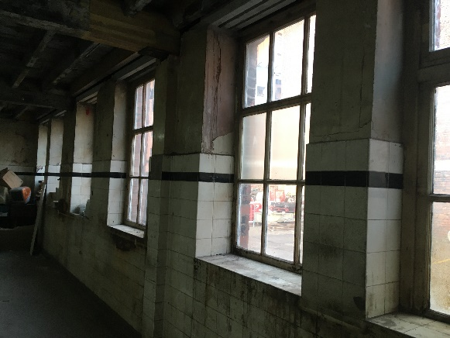 | General close-up view of internal North elevation wall (drawing T09 Section A-A). Proposal to strip back non-original plaster above tiles to reveal original brick work. Windows to be retained and overhauled.
A17 | 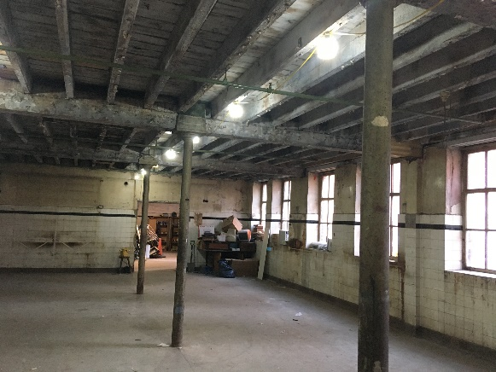 | General reverse view of internal North elevation wall (drawing T09 Section A-B). Proposal to strip back non-original plaster above tiles to reveal original brick work. Clean and retain ceramic tiles. Original steel columns to be retained and decorated.
A18 | 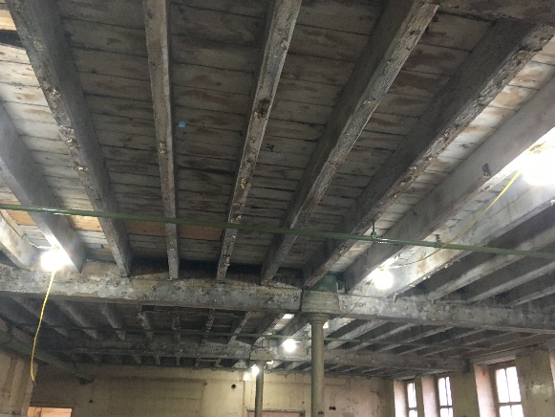 | General view of underside of North building B (ceiling) underside of first floor. To be lined with fire rated board.
A19 | 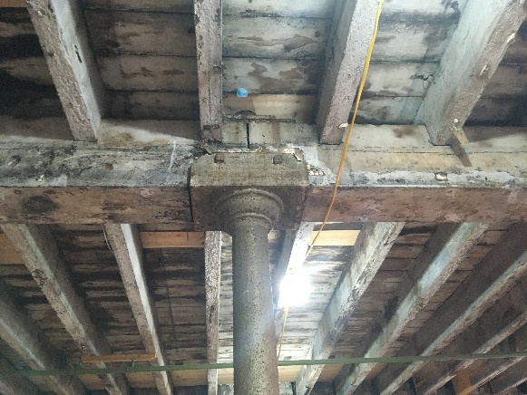 | View of typical supporting column arrangement to Building B
A20i | 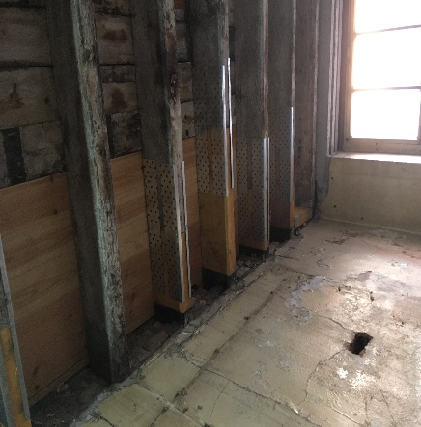 | Typical historic repairs to underside of North building B (ceiling) underside of first floor. To lined with fire rated board.
A20ii | 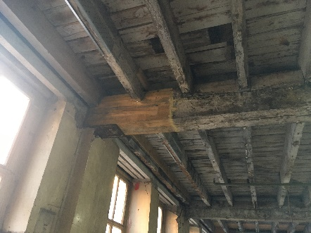
A21i  A21ii | 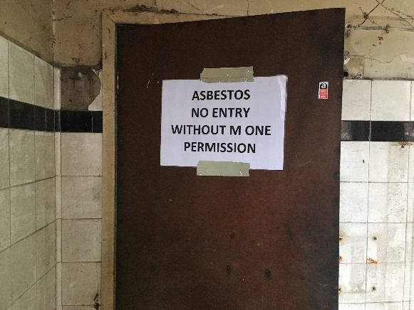  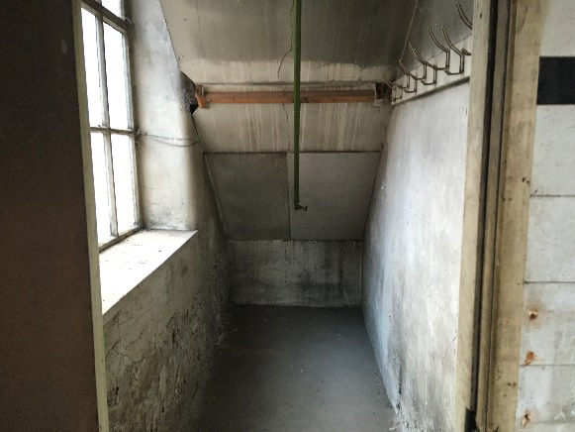 | Asbestos containing material to be removed
A22i | 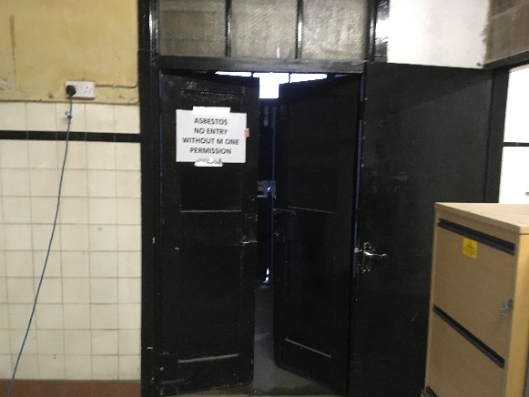 | General views of lobby behind Door D3. Non-original and Asbestos containing material to be removed
A22ii | 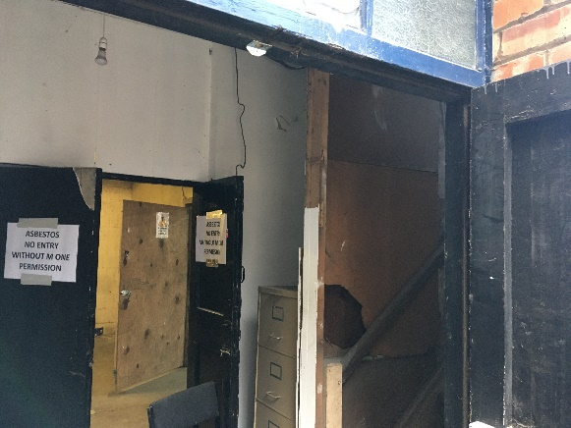
A23i | 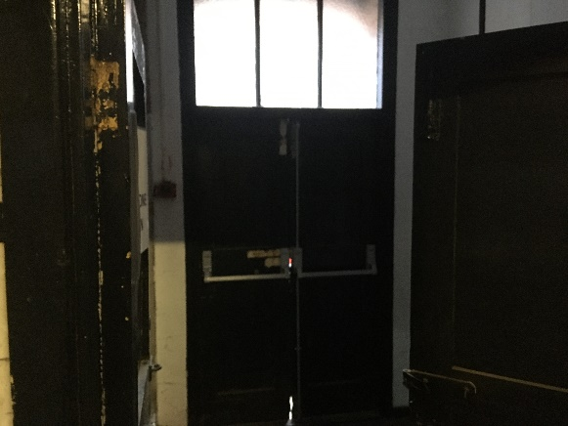 | Internal view of Door D3 to be retained, overhauled and converted to an accessible personnel door.
A23ii | 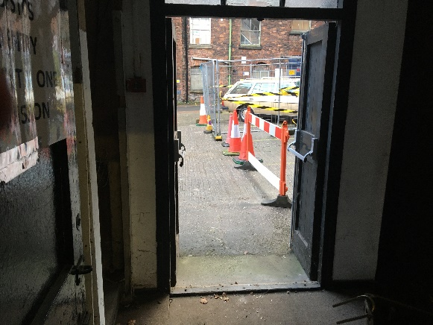 | Internal view of Door D3 to be retained, overhauled and converted to an accessible personnel door
A24i | 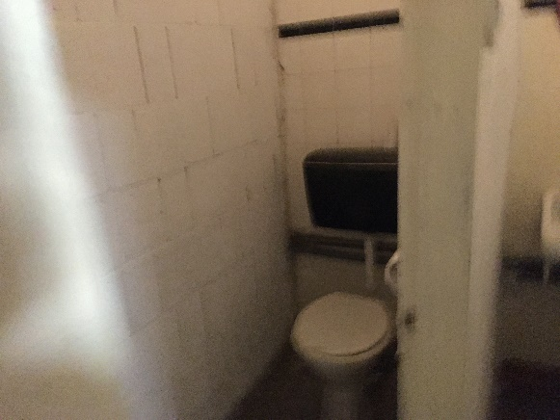 | General view of existing WC block. Non-original block wall and sanitaryware to be removed and existing utilities connections to be re-used.
A24ii | 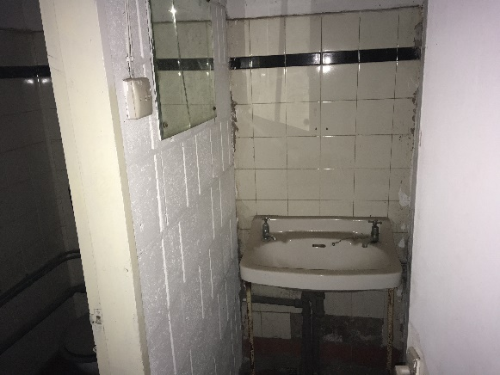
A24iii | 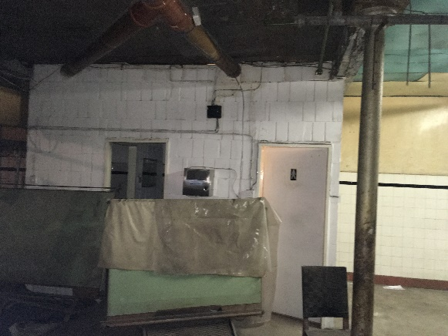
A25 | 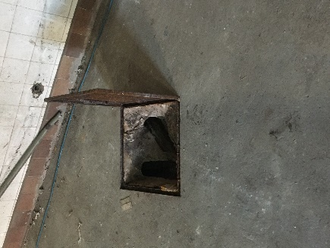 | Existing drainage connection to be re-used.
A26 | 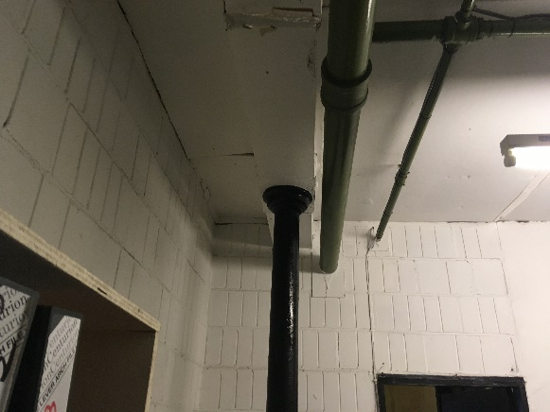 | Typical view of existing column non-complaint cladding to be removed and replaced.  Non-original block wall to be removed.
A27 | 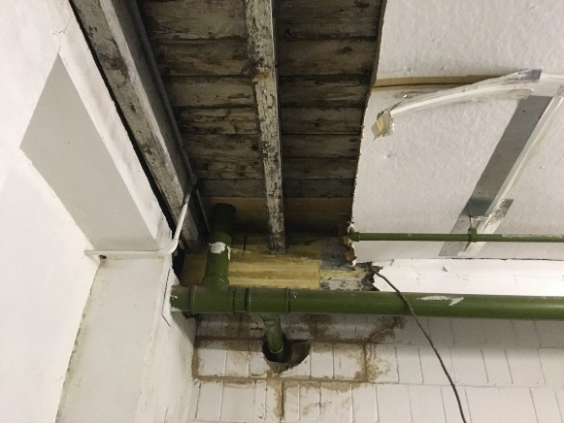 | Non-original damaged sheet to be removed and replaced.  Non-original block wall to be removed.

