Manchester City Council Our Ref: PK/TH/SPC………………..
Technical Support Team Your Ref:
Planning Date: 18th January 2020 2021
PO Box 532 Town Hall
Manchester
M60 2LA

Dear Sirs

RE: Address: Ground Floor Chatham Mill, 8 Lower Ormond Street, Manchester M1 5QP
Application number: 128758/FO/2020
Proposal: The change of use of the ground floor of the building from use class B8 (storage and
distribution) to use class E use (office) together with associated alterations

Further to your letter dated 14th December in relation to the above application submission, I will address each point in turn;

1) An amended Heritage Statement (v2) is now available, please also refer to the photographic record appended to the statement. Your comment regarding the proposed subdivision is noted and is addressed at paragraph 6.12 of Heritage Statement (v2) and also at Section 7 of the Design Access Statement (v2)

2) Amended drawings are now available for download

3) Design for Access 2 is addressed at section 6 of the Design and Access Statement, however, for the sake of clarity I confirm the proposal complies with Design for Access 2.

4) Traffic Management throughout the development is dealt with at section 12 of the Design Access Statement. However, it is envisaged that the application proposal will have negligible impact on the current provision.

5) A Waste Impact Statement is available for download.

6) The proposal to install air conditioning units has been omitted from the proposal (refer to Section 7 of the Heritage Statement) and consequently your request for confirmation in this respect is now obsolete.
6a) Please refer to point 6
6b) The proposals impact on the roofs is dealt with at section 6.15 of the Heritage Statement. The subject building’s roofs are outside of the design scope and are unaffected by the proposal and therefore they are not referenced and not included within this application.
6c) Scaled elevation drawings are available for download.
6d) Please refer to point 6 above
6e) With the exception of overhauling existing doors no other external works are proposed.
6f) Please refer to point 6 above

6g) Please refer to point 6 above
6h) please refer to point 6 above.
6i) Please refer to point 6 above.

If you would like to discuss this application further please either write to me at the above address, preferably via email as I will be working from home for the foreseeable future. Or, alternatively feel free to call me on 07384 252138

Yours sincerely

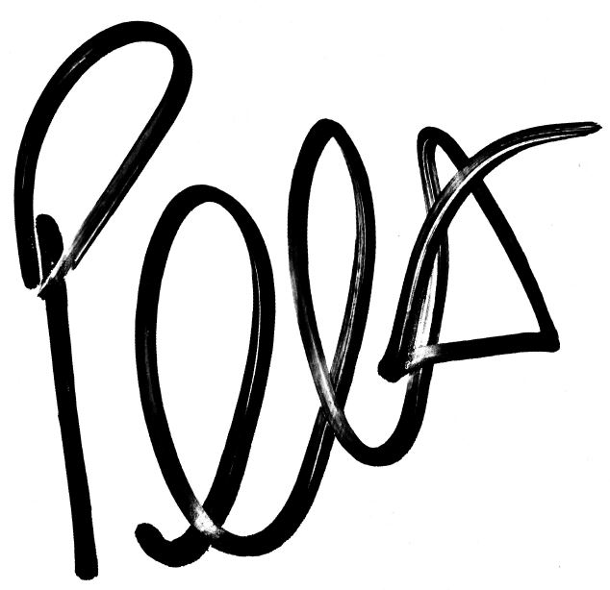

Peter Knight BSc (Hons) Building Surveying
Building Surveyor
For and on behalf of Scanlans

Office: 0161 236 8781
Mobile: 07384 252 138
Email: peter.knight@scanlans.com

