WASTE STRATEGY TO SUPPORT A PLANNING AND LISTED BUILDING CONSENT APPLICATION

FOR

CHATHAM MILL,
LOWER ORMOND STREET,
MANCHESTER

CLIENT – DANIEL JONES
M-One Studios Ltd

DATE – OCTOBER 2020
application ref: 128758/FO/2020 & 128759/LO/2020

To be read in connection with the following documents
- Drawings
  - T01.A1L - As Existing
  - T02.A3L - North Block - As Proposed
  - T04.A3L - Strip Out
  - T05.A1L – Elevations
  - T06.A3L Site Location Plan
  - T07.A3L Building Identification
  - T08.A3L - As proposed (2)
  - T09.A3L - Strip Out Sections
- 13102020 MATERIALS STATEMENT Chatham Mill Manchester (SPC10029)
- 13102020 HERITAGE STATEMENT (v2) Chatham Mill Manchester SPC10029
- 13102020 PLANNING STATEMENT (v2) Chatham Mill Manchester SPC10029
- 13102020 DESIGN STATEMENT (v2) Chatham Mill Manchester SPC10029
- xpelair-ventilation-guide

- INTRODUCTION

  - The following waste strategy has been written to accompany a planning application and listed building consent application for works to the ground floor of the north block of Chatham Mill, Manchester.

- REUSE AND ENVIRONMENTAL STATEMENT

  - Waste from the development will be segregated into 5 litre recycling bins provided at each desk within in each individual office. In addition 3 x 30 litre recycling bins located within the kitchen. These bins will be paper, glass, plastic and general unrecyclable refuse. On a daily basis the waste within these bins will be emptied by private cleaning and transferred to e1100 litre bins that are currently exist and located within demise of the development. 3 x 1100 litre bins are currently utilised at the development under an existing cleaning contract provision. It is not envisaged that additional waste containers nor collections over and above the existing provision will be necessary. B1 uses do not generate significant waste and it is not envisaged that any bags will be left at the end of the working day.

- CONCLUSION

  - B1 uses do not generate significant waste and it is not envisaged that any bags will be left at the end of the working day.

APPENDIX:

Waste Type | Capacity (litres per week) | Bin Capacity (litres) | No of Bins proposed | Proposed Location | Empty frequency
General | 60 | 30 | 1 | Kitchen | Daily transfer to existing 1100l containers
Pulpable | 110 | 5 | 22 | Offices | Daily transfer to existing 1100l containers
Mixed recycling | 60 | 30 | 1 | Kitchen | Daily transfer to existing 1100l containers
Food Waste | 60 | 30 | 1 | Kitchen | Daily transfer to existing 1100l containers
Has a contract been obtained with licences waste carrier |  | Contract exists
Details of waste and recycling segregation |  | Refer to drawings. Utilise existing provision for collection
Are all bins in the store accessible? |  | Yes
Are recycling facilities as easy to access as general waste |  | Yes
Has consideration been given to ventilation and hygiene |  | Yes
Who is responsible for placing bins at the collection point and returning them to the store. |  | Management Company
Proposed route for the collection vehicle will take |  | As existing weekly collection, no change.

Example Image of proposed additional 5 litre office bins | 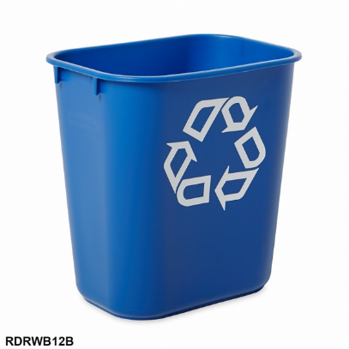
Example Image of proposed additional kitchen 30 litre bins cluster | 