Planning
Growth & Development
Delegated officer report for planning application

Application no. 129580/FH/2021
Date registered valid: 3 March 2021
Proposal: Erection of a two storey side extension to form additional living accommodation
Address: 1 Ashcott Avenue, Manchester, M22 9WS
Ward(s): Sharston Ward
Applicant: Mr Daniel Ellison, 43 Bagshaw Street, SK14 4TN
Agent (if any): Mr Daniel Vaughan, 43 Bagshaw Street, SK14 4TN
Case officer: Robert Griffin
Tel: 0161 234 4527
Email: robert.griffin@manchester.gov.uk
Recommendation: APPROVE
Date of recommendation: 22.04.2021

Application details

Type of application: Full Householder Application

Development type: Householder

Date of site visit: None undertaken due to Covid pandemic. Site photos were provided by applicant and online resources and MCC GIS system have also been reviewed.

Standard consultations:
No consultations have been printed and sent.

Neighbour notifications
Printed: 10 March 2021 Expired: 31 March 2021

Site notice
No site notice has been produced

Press advert
No press advert had been published

Departure from Development Plan: No

Environmental Statement: Not required

Description of site/building

Listed building: Not applicable

Conservation area: Not applicable

Tree Preservation Order: Not applicable

Description of area

The application property is a two storey end of terrace property with hipped roof set within a predominantly residential area. Ashcroft Avenue is a cul de sac with similar property types and character being present in the form of groups of 4 dwellings arranged in terraces. The property has a detached single storey garage to the side and a small rear garden with a majority of outdoor amenity space being to the front and side.

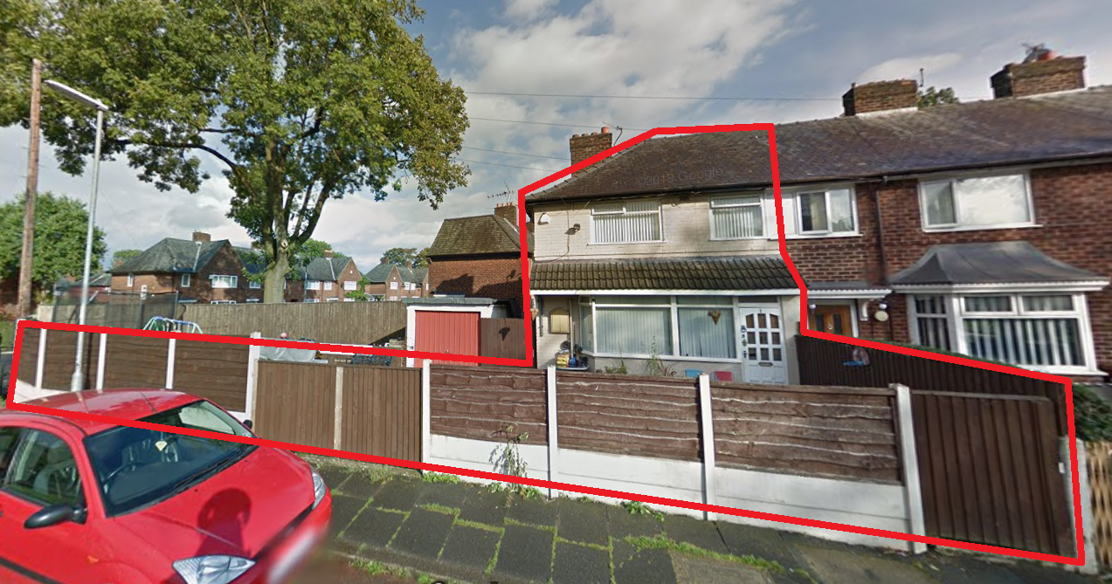
The application property

The application property is set at a 90 degree angle to the terrace of properties on Nearbrook Road with the closest at number 15, which shares a similar garden arrangement to the application property with its side garden being to the north of the application properties side garden.

Description of development

The application proposals seek to erect a two storey side extension set forward of the rear wall by 2 metres but extending to 4 metres in width to provide ground floor amenity space and utility room to the rear and additional front bedroom and rear ensuite bathroom on first floor. The eaves level of the extension would tie into the existing dwellinghouse and be set at a height of approx 4.6m whilst the ridge to the hipped roof would be set down from the main ridge and have a height of 6 m. The proposals are to be constructed of materials to match the existing property. The would be a slot window to the rear first floor and a window to the ground floor rear with a small side window at first floor. These windows would serve an ensuite and utility room as set out on the submitted floor plan drawings.

Consultations & Notification Responses

Neighbouring properties were notified of the proposals one objection was received in response. A summary of the comments made is set out below:
This application given me much concern and stress. I feel this build will affect my day to day life as this will take a lot of light from my front garden. As I only have a small back garden I spend a lot of time in my front. I suffer from severe psoriasis and I benefit a lot from the sun. The build will have a huge impact on my front garden especially the space I like to sit as it's the only space I get to sit in the sun . Please please would you take this into consideration as my front garden is my sanctuary I love my garden and all my plants and the thought of having this all shaded has really upset me . Could this not be a single storey?

Policy

Relevant policy to this application is contained in the NPPF (2019) and Core Strategy policies DM1 and SP1 and saved UDP policy DC1.

The National Planning Policy Framework sets out the Government's planning policies for England and how these should be applied. It provides a framework within which locally-prepared plans for housing and other development can be produced.

Planning law requires that applications for planning permission be determined in accordance with the development plan, unless material considerations indicate otherwise. The National Planning Policy Framework must be taken into account in preparing the development plan, and is a material consideration in planning decisions.

Achieving sustainable development means that the planning system has three overarching objectives, which are interdependent and need to be pursued in mutually supportive ways (so that opportunities can be taken to secure net gains across each of the different objectives):
a) an economic objective - to help build a strong, responsive and competitive economy, by ensuring that sufficient land of the right types is available in the right places and at the right time to support growth, innovation and improved productivity; and by identifying and coordinating the provision of infrastructure;
b) a social objective - to support strong, vibrant and healthy communities, by ensuring that a sufficient number and range of homes can be provided to meet the needs of present and future generations; and by fostering a well-designed and safe built environment, with accessible services and open spaces that reflect current and future needs and support communities' health, social and cultural well-being; and
c) an environmental objective - to contribute to protecting and enhancing our natural, built and historic environment; including making effective use of land, helping to improve biodiversity, using natural resources prudently, minimising waste and pollution, and mitigating and adapting to climate change, including moving to a low carbon economy.

Core Strategy policy DM1 indicates all development should have regard to the following specific issues for which more detailed guidance may be given within a supplementary planning document:-
- Appropriate siting, layout, scale, form, massing, materials and detail.
- Impact on the surrounding areas in terms of the design, scale and appearance of the
proposed development. Development should have regard to the character of the
surrounding area.
- Effects on amenity, including privacy, light, noise, vibration, air quality, odours, litter,
vermin, birds, road safety and traffic generation. This could also include proposals
which would be sensitive to existing environmental conditions, such as noise.
- Accessibility: buildings and neighbourhoods fully accessible to disabled people, access
to new development by sustainable transport modes.
- Community safety and crime prevention.
- Design for health.
- Adequacy of internal accommodation and external amenity space.
- Refuse storage and collection.
- Vehicular access and car parking.
- Effects relating to biodiversity, landscape, archaeological or built heritage.
- Green Infrastructure including open space, both public and private.
- The use of alternatives to peat-based products in landscaping/gardens within
development schemes.
- Flood risk and drainage.
- Existing or proposed hazardous installations.
Core Strategy policy SP1 states that the key spatial principles which will guide the strategic development of Manchester to 2027 include: the emphasis is on the creation of neighbourhoods of choice, providing high quality and diverse housing around district centres which meet local
needs, all in a distinct environment. The majority of new residential development in
these neighbourhoods will be in the Inner Areas, defined by the North Manchester
The Unitary Development Plan (UDP) for the City of Manchester (1995) - The Unitary Development Plan for the City of Manchester was adopted in 1995 and has largely been replaced with the policies contained within the Core Strategy. However, there are a number of policies that are extant.

Unitary Development Plan

Policy DC1 of the Unitary Development Plan seeks to accommodate the demand for more living space, while at the same time ensuring that the amenities of neighbours are protected, and that
the overall character of the surrounding area is not harmed. It relates specifically to residential extensions and the relevant criteria from this policy include:
DC1.1 The Council will have regard to:
a. The general character of the property
b. The effect upon the amenity of neighbouring occupiers
c. The overall appearance of the proposal in the street scene;
d. The effect of the loss of any on-site car-parking
Policy DC1.2 states extensions will be allowed subject to:
a. They are not excessively large or bulky (for example, resulting in structures which are not subservient to original houses or project out too far in front of the original buildings)
b. They do not create a loss of sunlight/daylight or privacy
c. They are not out of character with the style of development in the area
d. They would not result in the loss of off-street parking

Policy DC1.3 states that notwithstanding the generality of the above policies, the Council will not normally approve:
a. rearward extensions greater than 3.65m (12 ft) in length;
b. 2-storey extensions with a flat roof, particularly those which would be visible from the public
highway;
c. 2-storey extensions to terraced properties which occupy the full width of the house;
d. flat roofed extensions to bungalows;
e. extensions which conflict with the Council's guidelines on privacy distances (which are
published as supplementary guidance).

Policy DC1.4 indicates that in considering proposals for 2-storey side extensions, the Council will have regard to the general guidance above and also to supplementary guidance to be issued. In particular, the Council will seek to ensure that:
a. the development potential of the gap between detached and semi-detached houses is capable of being shared equally by the owners or occupiers of the two properties concerned;
b. the actual or potential result of building the extension will not be the creation of a terracing
effect, where this would be unsympathetic to the character of the street as a whole;
c. the actual or potential result of building the extension will not be the creation of a very narrow
gap between the properties, or any other unsatisfactory visual relationships between elements of the buildings involved.
As a guide, and without prejudice to the generality of this policy, the Council will normally permit
2-storey house extensions which, when built, would leave a minimum of 1.52m (5 ft) between the side wall and the common boundary, and which meet the other requirements of this policy.
Proposals which cannot meet these requirements will be judged on their merits, but with weight
being given to (a) and (c) above.

Issues

The principle of householders extending their properties to provide additional living accommodation is generally acceptable subject to further consideration of the impacts of proposals on residential amenity and the character of the area.

Residential Amenity - The proposals are located to the side of the existing property in an area that currently incorporates a side detached garage. There is currently a dividing fence between the application property and number 15 Nearbrook Road.

The side extension is set forward of the rear wall of the existing house by approximately 2 metres, whilst windows are indicated at ground floor and first floor the relationship of these windows would be similar to existing windows in both the application property and 15 Nearbrook Road given the siting of these two properties in close proximity with small rear gardens. The proposals indicate that these windows would serve a ground floor utility and first floor ensuite room. Whilst this relationship is considered acceptable given the windows are additional to the existing ones it is considered that these rear facing windows should be obscurely glazed to reduce the perception of overlooking of the properties on Nearbrook Road. The proposals also incorporate an additional side facing first floor window to the ensuite and this window is considered to also require to be obscurely glazed. The proposals incorporate a side door at ground floor it is not considered that this would give rise to unacceptable impacts on residential amenity.

The front facing ground and first floor windows reflect the character and relationship to the street of the existing windows and are not considered to give rise to impacts on residential amenity.

Concerns have been raised by a neighbour about the impacts that the side extension would have on the front and side garden of their property and the potential for loss of sunlight and their enjoyment of this space. Given the orientation of the application property and the siting of the extension there maybe some loss of sunlight to the neighbouring properties side garden for the afternoon period due to the relationship of the extension being closer to this boundary. It is noted that the side plot would be in shadow presently for a period of time due to the existing relationship. It is acknowledged that there would be some loss of direct sunlight and overshadowing of the side garden and driveway to number 15 Nearbrook Road, it is not considered that these impacts would be so significant as to warrant refusal of the proposal.

The property at number 15 has its main front door on the side gable wall and two smaller windows which are assumed to serve the hall. Whilst the proposals would result in the built form being close to these doors and windows it is not considered that this would have an overbearing impact by virtue of the tapering of the boundary between the two properties which widens the gap between boundary and built form towards the front of the application property.

Visual amenity - The proposals have been designed to be subservient to the existing property by virtue of the set down of the ridge of the hipped roof. In addition due to the siting and relationship to the properties boundaries there would be a gap retained at the front from the side wall of the extension to the boundary of the site. The proposals are to be constructed utilising matching materials which will further assist in ensuring the proposals assimilate successfully.

Car parking - Whilst the proposals would result in the removal of the side garage there remains adequate driveway space for off road car parking.

Bins - Access to the side and rear will be maintained and as such bins can continue to be stored away from the front of the property.

Conclusion - The proposals are considered to be acceptable and not give rise to significant impacts on residential or visual amenity. As such it is considered that they are in accordance with the adopted planning policies and can be supported.

Human Rights Act 1998 considerations

This application needs to be considered against the provisions of the Human Rights Act 1998. Under Article 6, the applicants (and those third parties, including local residents, who have made representations) have a right to a fair hearing and to this end the local planning authority must give full consideration to their comments.

Protocol 1 Article 1, and Article 8 where appropriate, confer(s) a right of respect for a person’s home, other land and business assets. In taking account of all material considerations, including Council policy as set out in the Core Strategy and saved polices of the Unitary Development Plan, the Director of Planning, Building Control & Licensing has concluded that some rights conferred by these articles on the applicant(s)/objector(s)/resident(s) and other occupiers and owners of nearby land that might be affected may be interfered with but that that interference is in accordance with the law and justified by being in the public interest and on the basis of the planning merits of the development proposal. She believes that any restriction on these rights posed by the recommendation given is proportionate to the wider benefits of and that such a decision falls within the margin of discretion afforded to the Council under the Town and Country Planning Acts.

Recommendation: APPROVE

Article 35 Declaration

The application has been determined in a positive and proactive manner, in this instance conditions are proposed to be attached to any approval.

Condition(s) to be attached to decision for approval OR Reasons for recommendation to refuse

1) The development must be begun not later than the expiration of three years beginning with the date of this permission.

Reason - Required to be imposed pursuant to Section 91 of the Town and Country Planning Act 1990.

2) The development hereby approved shall be carried out in accordance with the following drawings and documents:
Drawing references: 2502 as received by the City Council as local planning authority on the 3rd March 2021

Reason - To ensure that the development is carried out in accordance with the approved plans. Pursuant to policies SP1 and DM1 of the Core Strategy.

3) The materials to be used on the external surfaces of the extension hereby permitted shall match those of the existing building in type, size, colour and texture as stated on the submitted application form and approved drawings.

Reason - To ensure the appearance of the building to be extended is not adversely affected by the materials to be used in the construction of the extension, pursuant to saved policies DC1.1, DC1.2 and DC1.4 of the Unitary Development Plan for the City of Manchester and policy DM1 of the Manchester Core Strategy.

4) Before first occupation the windows in the rear elevation ground and first floor together with the first floor side window shall be obscure glazed to a specification of no less than level 5 of the Pilkington Glass Scale or such other alternative equivalent and shall remain so in perpetuity.

Reason - To protect the amenity and living conditions of adjacent residential property from overlooking or perceived overlooking and in accordance with policies SP1 and DM1 of the Core Strategy.

5) Notwithstanding the provisions of the Town and Country Planning (General Permitted Development) Order 2015, (or any order revoking and re-enacting that Order with or without modification), no additional openings/windows/doors shall be inserted within the side extension hereby approved, unless Planning Permission is specifically granted.

Reason - In the interests of the amenities of the occupiers of neighbouring dwellinghouses, pursuant to saved policy DC1 of the adopted Unitary Development Plan for the City of Manchester, and policy DM1 of Manchester's Core Strategy.

Appendix 1 – List of consultees & neighbours notified

14 Nearbrook Road, Manchester, M22 9NS
115 Newhey Road, Manchester, M22 9WD
3 Ashcott Avenue, Manchester, M22 9WS
17 Nearbrook Road, Manchester, M22 9WT
15 Nearbrook Road, Manchester, M22 9WT
13 Nearbrook Road, Manchester, M22 9WT
120 Newhey Road, Manchester, M22 9ND
2 Ashcott Avenue, Manchester, M22 9WS
12 Nearbrook Road, Manchester, M22 9NT

Appendix 2 – Planning constraints

Article 4 Direction - Removal Of PD Rights Change Of Use From Class C3 To Class C4
Aircraft Safeguarding Zone - Aircraft Safeguarding Zone - All Exceeding 45M
Area Team Boundary - Name: SOUTH

