Planning
Growth & Development
Delegated officer report for planning application

Application no. 130125/FH/2021
Date registered valid: 21 April 2021
Proposal: Erection of front porch
Address: 20 Norleigh Road, Manchester, M22 4AZ
Ward(s): Northenden Ward
Applicant: Mr Ian Hilton 20 Norleigh Road, Manchester, M22 4AZ
Agent (if any): Mr Kayden Davies 153 Rake Lane, Manchester, M27 8RD
Case officer: Tracie Simpson
Tel: 0161 234 4537
Email: tracie.simpson@manchester.gov.uk
Recommendation: Approve
Date of recommendation: 9th June 2021

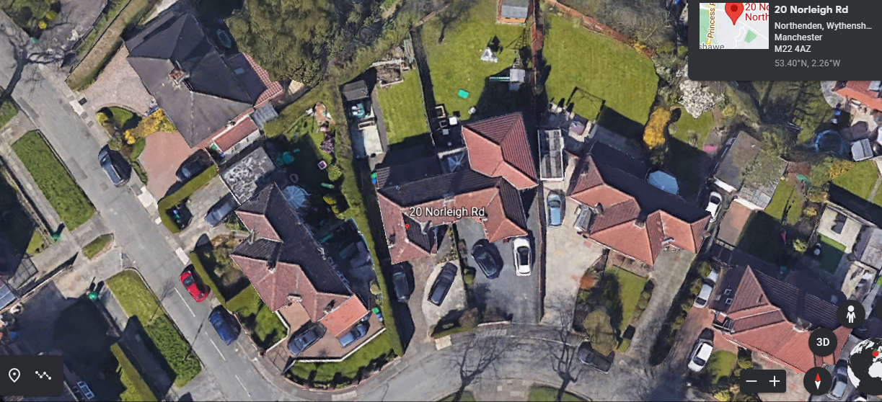

Application details

Type of application: Full Householder Application
Development type: Householder
Date of site visit:
Standard consultations: No consultations have been printed and sent.
Neighbour notifications Printed: 28 April 2021 Expired: 19 May 2021
Site notice No site notice has been produced
Press advert No press advert had been published
Departure from Development Plan: No
Environmental Statement: Not required

Description of site/building

The site comprises a two storey brick built semi-detached property in the Northenden area of Manchester. The property is typical of the butterfly design seen around the area. An attached garage is located on the side set forward of the adjacent property. An existing single storey side and rear extension is present with a mono pitch sloping roof to the rear of the garage which wraps around the property.

The roof is hipped reflecting the typical roof type within the area. The boundary has a small brick wall with hedging adjoining the public highway. The rear of the property is bounded by timber fencing, hedging and soft landscaping.

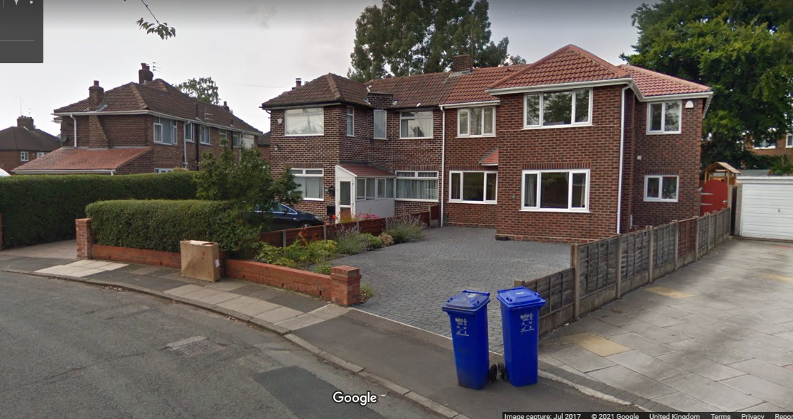

Listed building: Not applicable
Conservation area: Not applicable
Tree Preservation Order: Not applicable

Description of area

The area is predominantly residential in nature.

Description of development

The applicant is seeking to erect a front porch.

Consultations & Notification Responses
Local residents - as per Appendix 1 - Occupiers of properties surrounding the application site were notified of the proposal. No comments, objections or representations in respect of this application were received.

Policy and Issues

The following policies are considered relevant in the consideration of this application.

o Unitary Development Plan (UDP) - The UDP has been superseded by the Core Strategy Development Plan.
o Policy DC1 for Residential Extensions is still considered of relevance, in particular policy DC1.5 - The Council will consider on their merits exemptions to the above policies in the case of applications from disabled people who may require particular adaptations to their homes.
o The Manchester Core Strategy Development Plan Document 2012-2027 ("the Core Strategy") was adopted by the City Council on 11th July 2012.
o Policy DM 1 - Development Management
o Policy SP1 - Spatial Principles
o Policy EN1 - Design Principles
o Policy EN 19 - Waste Management
o The National Planning Policy Framework (NPPF)

For reasons to be outlined below, it is considered the proposal accords with the principles of this policy document.

Principle

The principle of allowing residents to extend their homes to provide enlarged or improved accommodation is generally acceptable provided that there is no overriding, undue impact upon either the character of the property or upon the residential and visual amenity of nearby residential occupiers.

In this instance the principle of the proposal is considered acceptable and it is not believed that there are any factors of sufficient weight in amenity terms that would warrant refusal of the application.

On balance, the proposed changes are deemed to accord with saved policy DC1 of the UDP and policies DM1 and SP1 of the Manchester Core Strategy.

History

There are no planning application relating to this site.

Residential Amenity

The applicant wishes to replace the existing porch with a slightly larger porch to provide additional living accommodation. The property has a butterfly type design to the front which is typical for the houses within this area some of which have front porches. The porch would occupy a space in the existing footprint at the front with an angled wall increasing in width that would be slightly wider than existing porch towards the rear. It would project 3.4 metres from the principle elevation of the property forming a partial infill to the front in line with the front elevation of the property. Measuring a total width of approximately 2.3 retaining a gap to the shared boundary with no. 18 Norleigh Road of 1.0 metres.

It would have a height to eaves of 2.2m and a maximum height of 3.0m. The porch would be sited approximately 1m from the boundary shared with No.18 and would be significantly set back from the public highway.

A window is proposed on the side elevation facing the adjacent property, however given that the proposal is for a porch, this is considered to be acceptable and is not thought would provide any further overlooking than that the front entrance to the property or the current window arrangement in the existing porch especially given the position of the entrances to the properties of other houses in the area where entrances are facing each other.

In terms of residential amenity, it is not considered that there will be any significant impact and the proposed development therefore accords with Core Strategy Policy DM1 and saved policy DC1 of the UDP.

Siting, scale and massing

The proposal exceeds the threshold for porches built under permitted development, however it would be proportional to this dwellinghouse and does not project beyond the principal elevation, therefore the location, scale and massing of the proposal is not believed to provide an overbearing impact upon the residential amenities of surrounding properties. The appearance is acceptable and its impact upon visual amenity is considered negligible.

It is therefore considered that the scale and mass of the proposed extensions are satisfactory and are considered to accord with the principles for residential extensions set out in saved UDP policy DC1, DM1 and EN1 of the Core Strategy.

Design

The design of the proposal would be in keeping with the existing and surrounding properties in the area. In terms of the proposed materials it is intended to use matching bricks and tiles as specified in the application form. The design of porch has been tailored to fit the shape of the existing property/plot and respect the relationship with the neighbouring property at the front and is considered acceptable and detailed as what is normally expected of such a structure.

On balance it is considered that the design and appearance of the proposed development accords with Core Strategy Policies DM1 and EN1 and in general the design is considered acceptable.

Disabled access

Not applicable

Bins

Bins storage is not affected by this proposal as space is retained along the side of the property and therefore the storage of refuse bins accords with policy EN19 of the Core Strategy.

Parking

Off street car parking would be retained to the site and therefore it is considered that car parking arrangements are not affected by this proposal.

Conclusion

Although the proposal would be visible from the public highway and therefore would be a feature within the street scene, the character of the area is still retained. The proposal has been sited and designed to ensure that it is subservient to the original dwellinghouse and the proposal is considered acceptable in this location, in terms of design, scale and massing, allowing the occupiers to adapt their home to meet their needs, without unduly detrimentally affecting the amenities of the occupiers of surrounding properties, or the character and appearance of the surrounding street scene, and there are no material considerations of sufficient weight to indicate otherwise.

Human Rights Act 1998 considerations

This application needs to be considered against the provisions of the Human Rights Act 1998. Under Article 6, the applicants (and those third parties, including local residents, who have made representations) have a right to a fair hearing and to this end the local planning authority must give full consideration to their comments.

Protocol 1 Article 1, and Article 8 where appropriate, confer(s) a right of respect for a person’s home, other land and business assets. In taking account of all material considerations, including Council policy as set out in the Core Strategy and saved polices of the Unitary Development Plan, the Director of Planning, Building Control & Licensing has concluded that some rights conferred by these articles on the applicant(s)/objector(s)/resident(s) and other occupiers and owners of nearby land that might be affected may be interfered with but that that interference is in accordance with the law and justified by being in the public interest and on the basis of the planning merits of the development proposal. She believes that any restriction on these rights posed by the recommendation given is proportionate to the wider benefits of and that such a decision falls within the margin of discretion afforded to the Council under the Town and Country Planning Acts.

Recommendation: Approve

Article 35 Declaration

Officers have worked with the applicant in a positive and proactive manner based on seeking solutions to problems arising in relation to dealing with the planning application. No significant problems have arisen during the consideration of this application and the application has been determined in a timely manner, in accordance with the policies with the Development Plan.

Condition(s) to be attached to decision for approval OR Reasons for recommendation to refuse

1) The development must be begun not later than the expiration of three years beginning with the date of this permission.

Reason - Required to be imposed pursuant to Section 91 of the Town and Country Planning Act 1990.

2) The development hereby approved shall be carried out in accordance with the following drawings and documents:

Received on 21st April 2021 numbered 001 Rev A Existing and Proposed Plans and Elevations

Reason - To ensure that the development is carried out in accordance with the approved plans. Pursuant to policies SP1 and DM1 of the Core Strategy.

3) The materials to be used on the external surfaces of the porch extension hereby permitted shall match those of the existing building in type, size, colour and texture, as stated on the submitted application form.

Reason - To ensure the appearance of the building to be extended is not adversely affected by the materials to be used in the construction of the extension, pursuant to saved policies DC1.1, DC1.2 and DC1.4 of the Unitary Development Plan for the City of Manchester and policy DM1 of the Manchester Core Strategy.

Appendix 1 – List of consultees & neighbours notified

33 Woodburn Road, Manchester, M22 4BZ
35 Woodburn Road, Manchester, M22 4BZ
31 Woodburn Road, Manchester, M22 4BZ
18 Norleigh Road, Manchester, M22 4AZ
15 Norleigh Road, Manchester, M22 4AY
13 Norleigh Road, Manchester, M22 4AY

Appendix 2 – Planning constraints

Article 4 Direction - Removal Of PD Rights Change Of Use From Class C3 To Class C4
Aircraft Safeguarding Zone - Aircraft Safeguarding Zone - All Exceeding 90M
Susceptible to Surf Water Flood (Less) -
Area Team Boundary - Name: SOUTH

