Planning
Growth & Development
Delegated officer report for planning application

Application no. 129337/FO/2021
Date registered valid: 11 February 2021
Proposal: Erection of single storey rear extension and change of use of premise from (Class E Retail) to Place of Worship (Class F1 (g) use)
Address: 181 Mauldeth Road, Manchester, M19 1BA
Ward(s): Burnage Ward
Applicant: Iftikhar Amin 181 Mauldeth Road, Manchester, M19 1BA
Agent (if any): Mr Ahmed Choudhry Nada Architects 169 Kingsway, Manchester, M19 2ND
Case officer: Linda Marciniak
Tel: 0161 234 4636
Email: linda.marciniak@manchester.gov.uk
Recommendation: Approve
Date of recommendation: 3 June 2021

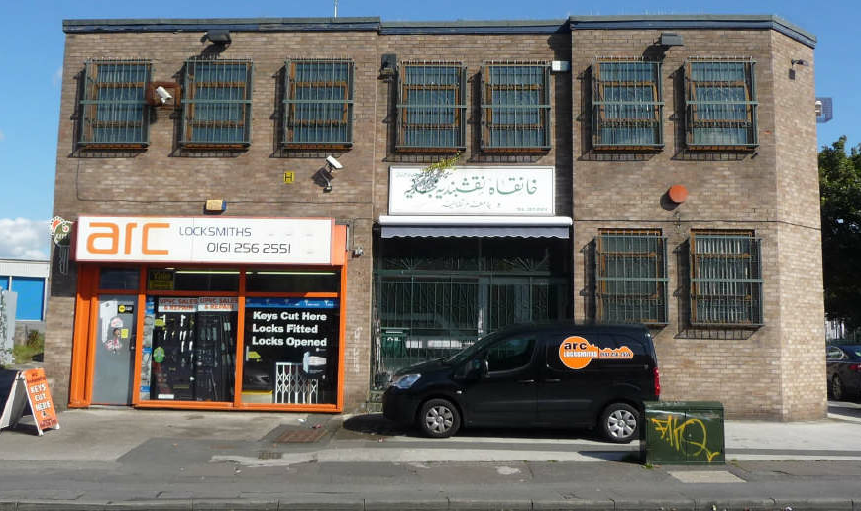
Application details

Type of application: Full Application Consent
Development type: Minor Other
Date of site visit: Photos provided by agent
Standard consultations: Printed: 15 March 2021 Expired: 5 April 2021
Neighbour notifications Printed: 15 March 2021 Expired: 5 April 2021
Site notice No site notice has been produced
Press advert No press advert had been published
Departure from Development Plan: No
Environmental Statement: Not required
Listed building: Not applicable
Conservation area: Not applicable
Tree Preservation Order: Not applicable

Description of site/building
The application site is a single shop unit of 35sqm fronting onto Mauldeth Road, and a triangular parcel of car park land at the rear with 4no. spaces. It forms part of a 612sqm 2-storey building in use as a mosque since gaining Secretary of State approval in 1996.

The site is situated on the northern side of Mauldeth Road in the Burnage ward. It has a separate large car park fronting onto the A34 Kingsway accessed from Harwood Road, and a brick-built electricity sub-station within the smaller rear car park.

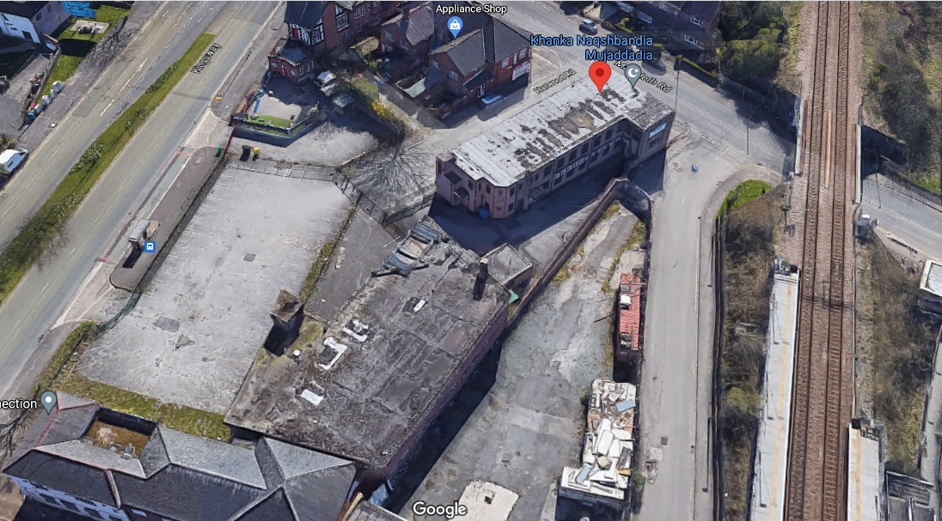
Aerial view of the site looking south with development area in red boundary and main car park edged in blue.

It is bounded in part by a parcel of vacant land at 179 Mauldeth Road to the west and the unadopted road. This road is within the Network Rail Order Lands and gives access to both Mauldeth Road railway station and a large A1 retail store further north. West of this are the railway sidings and the railway. Harwood Road to the east also gives access to Harwood House / Kingsway Business Centre whilst to the south is inter-war residential housing.

Description of area
The site is located close to the busy intersection of the A34 Kingsway and Mauldeth Road. East of Harwood Road is a parade of 4no. shop units and a children’s nursery in the former Mauldeth Hotel at the junction with the A34, with a cluster of other small commercial units located on the eastern side of Kingsway.

Residential housing forms the character of the wider hinterland outside of this mixed commercial cluster.

The site is well served by public transport with frequent bus services along the A34 and trains between Manchester city centre and the airport stopping at Mauldeth Road.

Description of development
Erection of single storey rear extension and change of use of premise from (Class E Retail) to Place of Worship (Class F1 (g) use).

The application is similar in purpose, design and scale to application 104914/FO/2014/S2 which was approved in July 2014 but never implemented.

As with the 2014 application, the extension together with the proposed change of use, would provide 154sqm of additional floorspace which is to provide extended storage facilities for chairs and equipment with a separate shoe storage area towards the extended rear section.

The application is accompanied by a Design and Access Statement which sets out the detail of the proposal. Further clarification and details were provided by the agent following comments raised by Highway Services.

Consultations & Notification Responses
Neighbour notifications – No comments received.

Highway Services
The site is adjacent to the junction of the adopted highway Mauldeth Road. An unadopted
unnamed road sits to the West and unadopted Harwood Road sits to the East. A 20mph speed restriction is in place on Mauldeth Road.

There is a strip of private forecourt located to the property's frontage.

SITE ACCESSIBILITY:
The site is located within a reasonably sustainable location with access to various bus services operating along Mauldeth Road and Kingsway alongside Mauldeth Road Train Station, providing links to Manchester city centre and the surrounding area.

PARKING AND ACCESS:
To the rear of the property there is a 4No. space car park. The existing gated access point is accessible from Harwood Road. Confirmation is sought to cover the following:
o Existing and proposed visitor sizes
o Anticipated increase in trip levels
o Number of events/sessions held daily
o Existing and Proposed staff levels
o Anticipated session start-finish times
o Intended Parking Locations
Highways have concerns that should number to trips to the Centre increase, there is insufficient car parking to cater for these vehicles.

CYCLE PARKING
It is recommended that secure sheltered cycle storage is made available for staff and visitors, in line with MCC Core Strategy.

REFUSE AND SERVICING:
Limited information is offered regarding refuse and servicing. It would be useful to understand the refuse and servicing arrangements in more detail, to ensure there is no obstruction on the highway.

BOUNDARY TREATMENTS:
All boundary treatments with frontage to the adopted highway must ensure appropriate visibility and therefore be visually permeable from a preferred height of 600mm upwards to ensure that child pedestrians are visible when accessing / egressing a site.

FIT-OUT ARRANGEMENTS:
Detail is sought from the applicant in relation to the proposed construction arrangements from a highways perspective covering the type of vehicular movements anticipated together with any associated proposals for delivery, storage and disposal / collection of materials.

The applicant is advised that any requirements for licensing, hoarding / scaffolding and any associated temporary traffic management arrangements will need discussion and agreement with the council's Highways Applications and Network Resilience teams via Contact Manchester (Tel. 0161 234 5004).

Environmental Health
Construction/demolition works shall be confined to the following hours unless otherwise agreed in writing by the City Council as local planning authority:

Monday - Friday: 7.30am - 6pm
Saturday: 8.30am - 2pm
Sunday / Bank holidays: No work

Reason - To safeguard the amenities of the occupiers of nearby residential and commercial properties during the construction/demolition phase.

Greater Manchester Police
1. Any new external doors or windows must be certified to BS PAS 24 or LPS 1175 SR2.
2. Any new ground floor glazing must incorporate a pane of laminate glass to a minimum thickness of 7.5mm.
3. It is recommended that the building is covered by a monitored alarm system.
4. Consideration should be given to installing a comprehensive CCTV system.

Network Rail
Network Rail has no objection in principle to the proposal but have several requirements for works within 10 metres of their operational land. These relate to submission of a risk assessment and method statement for all construction works, details of scaffolding, surface and foul water drainage and earthworks.

Guidance has been provided on how the above details are to be reviewed and assessed.

HSE - Guidance sent in relation to safe working and overhead lines / underground power supply.

Electricity North West – Guidance provided on safe working in relation to electricity infrastructure on site.

Issues
Policy
Core Strategy policies SP1, DM1, T2 and EN19 and the NPPF are material to the proposal.

Principle
The application seeks a change of use of a small retail unit and a rear single storey infill extension to provide additional storage space to an established place of worship.

As set out in the Design and Access Statement, the shop unit is in the ownership of the applicant and the decision has been taken to incorporate it into the footprint of the site after failing to secure a commercial use since the last business, a locksmith, vacated the premises.

The mosque is a popular local facility, but internal storage is poorly catered for. At present, chairs and equipment compete with circulation space and shoe storage which, according to tradition, should be kept at the entrance and separate to the prayer hall. The cramped facilities also creates a bottleneck on leaving the building with stored chairs and equipment being obstacles to safe and efficient egress.

The proposal enables a larger storage area in the shop unit and extension, with separate shoe storage towards the rear at the main entrance, and better internal circulation.

There are no objections to the proposal in principle subject to satisfactory compliance with policies managing impacts on residential and visual amenity, and operation of the railway.

Residential amenity
The residential amenity impacts are acceptable for this application. The nearest residential property is No.180 Mauldeth Road which is 24 metres across the road from the site to the south.

The mosque presently has a capacity to hold 463 worshippers in total but the average occupancy during each of the 5 prayer sessions is approximately 40no. persons. Worshippers can access the large car park via Harwood Road and there are no proposed changes to these arrangements or numbers attending. As a result, there would be no additional parking demand created which will ensure that current parking arrangements for nearby residents is unaffected. This includes parking on street as it is noted that this section of Mauldeth Road is not managed by any double yellow line Traffic Regulation Orders.

Prayer session times vary according to the calendar which are determined by sunrise and sunset hours but no more than 5no. session per day are held throughout the year.

The agent has also confirmed that the 4no. parking spaces at the rear of the site are not used for parking as all parking takes place in the larger dedicated car park fronting onto Kingsway.

Highway Services requested details of cycle parking, boundary treatment and fit out arrangements which the agent confirmed in detailed correspondence and a revised drawing.

Based on the above, the proposal is considered to have acceptable impacts on residential amenity.

Visual amenity
The extension will also have an acceptable impact on visual amenity. Seen from the front elevation, it will sit behind the building line on the western side of the main 2-storey building with the shop unit remaining as existing.

As the site is triangular, the extension follows the contours of the site, splaying out behind the shop unit. From Mauldeth Road, a 7-metre wide section would be partially visible as it runs parallel to the western boundary shared with the unadopted road and vacant land. A section of the existing brick boundary wall will be removed to facilitate the build to the boundary. At the rear, the footprint has a width of 10.34-metres. There is no view of this elevation which is nonetheless conforming with the 2-storey building.

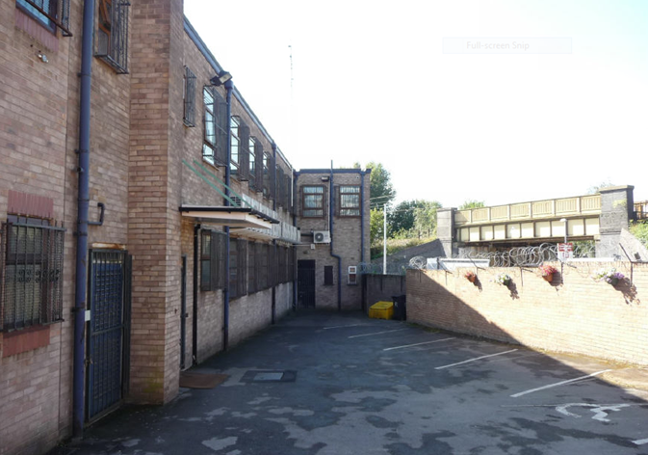
As with the application approved in 2014, the design is simple with a flat roof extending to 3.26 metres in height. The roof is populated with domed lanterns and on the western elevation, several obscurely glazed windows in white uPVC frames run the length of the building. These will enable the space to be well lit and properly ventilated. They will also enliven the appearance of the building and relieve the mass of brickwork to positive effect. Elsewhere, matching brick materials are proposed for the elevations. These are required to match by way of condition on any approval.

The arrangement of windows replicates the existing. All windows and doors across the building at present are secured by externally mounted steel bars. There are no bars shown on the new elevation shared with the vacant land alongside, and GMP have not specified them as a requirement. Securing the extension is however recommended by use of certified safety standard 7.5mm minimum thick laminate glazing and through an alarm system and CCTV monitoring. These recommendations are appended as an Informative at the end of this report.

For the above reasons, the proposal will have an acceptable impact on the appearance of the building.

Cycle parking
Cycle parking was not originally proposed as there is no uplift in numbers. However, there is an opportunity to widen the choice of transport options to and from the site and help futureproof it by reducing carbon emissions. Provision of a secure cycle parking facility has therefore been made. This is shown at the northern end of the site adjacent to the electricity sub-station on the revised site plan drawing Ref: (01)001 PL1.

Refuse and servicing
Highways sought additional details on the waste and servicing arrangements to ensure that there is no obstruction of the highway.

The agent confirmed that as the mosque is for prayer purposes only, very little waste is generated. No food is consumed on the premises and any general waste is at a low level with basic admin work taking place in the office. Waste is collected by a licensed waste carrier on a regular basis and there are plans to change these arrangements in this application.

Boundary treatments
Highway Services requested details of those boundary treatments with a highway frontage to ensure child safety when accessing and egressing the site.

No amendments are proposed to the boundary treatment except as described above. The agent has confirmed that the existing arrangements would be maintained which include 2.3-metre high railings with 100mm spacings. These give clear inter-visibility from either side of vehicles and pedestrians.

Fit-out arrangements
Highways sought further clarification of the details of the fit-out arrangements to ensure that there is no obstruction to the highway during construction.

The agent confirmed that materials would be delivered, and waste collected as required from site by skip hire or grab-wagon licenced firm. Contractors would be able to park in the 4no. parking spaces at the rear whilst the extension was under construction. These arrangements are appropriate for the build out of the proposal. An Informative managing construction hours is appended at the end of this report in the interests of residential amenity.

Network Rail
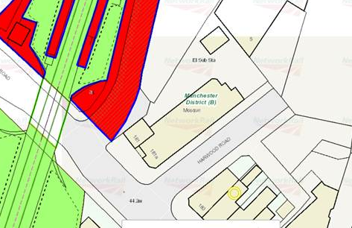
Network Rail have confirmed that the unadopted road lies within the curtilage of their Order Lands (shaded red and green). As such, the site (edged red on the plan) lies within 10 metres of the boundary and interface with the railway and so conditions are recommended to ensure that the works are carried out safely.

The applicant is required to liaise with Network Rail to agree to an undertaking with them to permit supervision of the construction in the interests of protecting the safe operation and integrity of the railway, and the rail authority’s assets.

The rail operator has confirmed that the applicant is required to provide further details of a method statement and risk assessment for the works directly to Network Rail. This is appended as an Informative at the end of this report.

Details are also required for the means of discharging surface and foul water drainage for which a condition is appended.

Development is also expected to ensure that a 3-metre gap is retained between the site and railway support zones and lineside cabling and that ground instability does not result from excavations and earthworks. Conditions are appended at the end of this report to this effect.

Conclusion
The proposal represents an acceptable development to an existing place of worship to provide much needed additional storage space, with no proposed uplift in numbers. There is no change in the proposal from the application approved in 2014.

There will be little perceptible visual change to the front elevation as viewed from Mauldeth Road with development appearing as subservient to the main building and in materials to match the original.

Conditions are appended to ensure that the development proceeds in accordance with the recommendations for security of the extended building and to safeguard the assets of the rail transport authority on nearby land.

On the basis of the above, the proposal accords with policies SP1, DM1, T2 and EN19 of the Manchester Core Strategy and with the general provisions of the NPPF.

Human Rights Act 1998 considerations
This application needs to be considered against the provisions of the Human Rights Act 1998. Under Article 6, the applicants (and those third parties, including local residents, who have made representations) have a right to a fair hearing and to this end the local planning authority must give full consideration to their comments.

Protocol 1 Article 1, and Article 8 where appropriate, confer(s) a right of respect for a person’s home, other land and business assets. In taking account of all material considerations, including Council policy as set out in the Core Strategy and saved polices of the Unitary Development Plan, the Director of Planning, Building Control & Licensing has concluded that some rights conferred by these articles on the applicant(s)/objector(s)/resident(s) and other occupiers and owners of nearby land that might be affected may be interfered with but that that interference is in accordance with the law and justified by being in the interest and on the basis of the planning merits of the development proposal. She believes that any restriction on these rights posed by the recommendation given is proportionate to the wider benefits of and that such a decision falls within the margin of discretion afforded to the Council under the Town and Country Planning Acts.

Recommendation: Approve

Article 35 Declaration
The local planning authority in making its decision has had due regard to paragraph 47 of the National Planning Policy Framework as well as the development plan, national planning policy and other material considerations and has approved the application subject to appropriate conditions and for the reasons outlined in the delegated report. The application received no objections on notification but was subject to the receipt of further information to clarify the highways implications of the proposal. Conditions are appended below in the interests of residential and visual amenity and safe operation of the nearby railway operator’s land.

Condition(s) to be attached to decision for approval OR Reasons for recommendation to refuse

1) The development must be begun not later than the expiration of three years beginning with the date of this permission.

Reason - Required to be imposed pursuant to Section 91 of the Town and Country Planning Act 1990.

2) The development hereby approved shall be carried out in accordance with the following drawings and documents received as stated:

Application Form 08 Feb 2021
Drawing - Location Plan 08 Feb 2021
Drawing - Location Plan 08 Feb 2021
Drawing - Existing Ground Floor Plan 08 Feb 2021 (02 )001
Drawing - Existing Elevations 08 Feb 2021 (03)001
Drawing - Existing Elevations and Sub-Station 08 Feb 2021 (03)002
Drawing - Existing & Proposed Site Plans 08 April 2021 (01)001 PL1
Drawing - Proposed Ground Floor Plan 08 Feb 2021 (07)001 PL0
Drawing - Proposed General Arrangement Elevations 1 08 Feb 2021 (08)001 PL0
Drawing - Proposed General Arrangement Elevations 2 08 Feb 2021 4 (07)002
Drawing - Proposed Rear Elevation 11 Feb 2021 (02)002 PL0
Design & Access Statement prepared by Ahmed Choudhry 08 Feb 2021
Photos 10 Feb 2021

Reason - To ensure that the development is carried out in accordance with the approved plans. Pursuant to policies SP1 and DM1 of the Core Strategy.

3) The materials to be used on the external surfaces of the extension hereby permitted shall match those of the existing building in type, size, colour and texture, as stated on the Application Form.
Reason: In order to ensure a satisfactory appearance in the interests of visual amenity in accordance with policies SP1 and DM1 of the Manchester Core Strategy and the requirements of the National Planning Policy Framework.
4) Before first occupation the windows in the side elevation as shown on drawings (07)001 revision PL0 and (08)001 revision PL0 received by the City Council as Local Planning Authority on the 02 February 2021, shall be obscure glazed to a specification of no less than level 5 of the Pilkington Glass Scale or such other alternative equivalent and shall remain so in perpetuity.

Reason - To protect the amenity and living conditions of adjacent residential property from overlooking or perceived overlooking and in accordance with policies SP1 and DM1 of the Core Strategy.

5) Prior to the installation of any drainage system, details of the disposal of both surface water and foul water drainage shall be submitted to and approved in writing by the City Council as Local Planning Authority. The drainage design shall demonstrate how foul and surface water is to be directed away from the railway and shall be constructed and maintained only in accordance with the approved plans.

Reason: To protect the adjacent railway from the risk of flooding, soil slippage and pollution in accordance with policy EN17 of the Manchester Core Strategy.

6) Prior to the commencement of the development full details of ground levels, earthworks and excavations to be carried out near to the railway boundary shall be submitted to and approved in writing by the City Council as Local Planning Authority. The earthworks and excavations shall only be undertaken in accordance with the approved plans.

Reason: To protect the adjacent railway.

7) Any scaffolding which is to be erected /constructed within 10 metres of a boundary to a railway line must be erected in such a manner that at no time will any poles over-sail the railway line. A method statement giving details of measures to be taken to prevent construction materials from the development reaching the railway (including protective fencing) shall be submitted to and approved in writing by the City Council as Local Planning Authority before the any above ground development commences.

The measures including protective fencing) to prevent any construction materials from the development reaching the railway line hereby approved shall be implemented in full before development commences.

Reason - In the interests of railway safety.

8) The development shall ensure that a gap of 3-metres is retained between the site and railway support zones and lineside cabling at all times during construction.

Reason – In the interests of railway safety.

Informatives

1) Construction/demolition works shall be confined to the following hours unless otherwise agreed in writing by the City Council as local planning authority:

Monday - Friday: 7.30am - 6pm
Saturday: 8.30am - 2pm
Sunday / Bank holidays: No work

Reason - To safeguard the amenities of the occupiers of nearby residential and commercial properties during the construction/demolition phase.

2) Prior to works commencing, a Method Statement and Risk Assessment covering all works within 10 metres of the operational railway must be submitted directly to Network Rail at the following address: https://www.AssetProtectionLNWNorth@networkrail.co.uk for review and agreement.

Reason: To ensure that the construction and subsequent maintenance of the proposal can be carried out without adversely affecting the safety, operational needs or integrity of the railway.

3) The applicant should refer to https://secure.manchester.gov.uk/info/100006/environmental_problems/2956/noise/9 and IAQM/EPUK Construction Guidance at: http://iaqm.co.uk/guidance/.

4) 1. Any new external doors or windows must be certified to BS PAS 24 or LPS 1175 SR2.
2. Any new ground floor glazing must incorporate a pane of laminate glass to a minimum thickness of 7.5mm.
3. It is recommended that the building is covered by a monitored alarm system.
4. Consideration should be given to installing a comprehensive CCTV system.

5) The applicant is required to have regard to the guidance provided in the email dated 9th of June 2021 to the agent in relation to safe working in the vicinity of the electricity sub-station. Further details can be found at: https://www.enwl.co.uk/our-services/know-before-you-dig

Appendix 1 – List of consultees & neighbours notified
Highway Services
Environmental Health
Greater Manchester Police
Electricity Northwest
Network Rail

183 - 185 Mauldeth Road, Manchester, M19 1BA
179 Mauldeth Road, Manchester, M19 1BA
5 Harwood Road, Manchester, M19 1TN
Khankah Naqashbandia, 181A Mauldeth Road, Manchester, M19 1BA
First Floor, 189 Mauldeth Road, Manchester, M19 1BA
187A Mauldeth Road, Manchester, M19 1BA
187 Mauldeth Road, Manchester, M19 1BA
189 Mauldeth Road, Manchester, M19 1BA
186 Mauldeth Road, Manchester, M19 1BF
184 Mauldeth Road, Manchester, M19 1BF
182 Mauldeth Road, Manchester, M19 1BF
180 Mauldeth Road, Manchester, M19 1BF

Appendix 2 – Planning constraints

Article 4 Direction - Removal Of PD Rights Change Of Use From Class C3 To Class C4
Aircraft Safeguarding Zone - Aircraft Safeguarding Zone - All Exceeding 90M
Area Team Boundary - Name: SOUTH

