Planning
Growth & Development
Delegated officer report for planning application

Application no. 130056/FH/2021
Date registered valid: 19 April 2021
Proposal: Erection of a part single, part two storey side and part single, part two storey rear extension and porch to front to provide additional living accommodation
Address: 12 Delacourt Road, Manchester, M14 6BX
Ward(s): Old Moat Ward
Applicant: Mohammed Abdul Kayum 74 Brynton Road, Manchester, M13 0UY
Agent (if any): Mr Rashid Mehmood I Planning Services 6B Cook Street, Bury, BL9 0RP
Case officer: Linda Marciniak
Tel: 0161 234 4636
Email: linda.marciniak@manchester.gov.uk
Recommendation: Approve
Date of recommendation: 10 June 2021

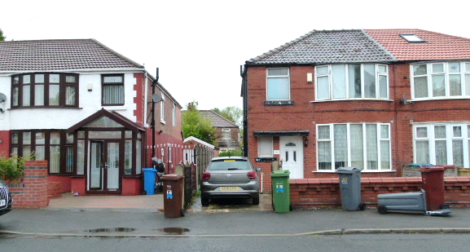
Application details

Type of application: Full Householder Application

Development type: Householder

Date of site visit: 20 May 2021

Standard consultations:
Printed: 4 May 2021 Expired: 25 May 2021

Neighbour notifications
Printed: 4 May 2021 Expired: 25 May 2021

Site notice
No site notice has been produced

Press advert
No press advert had been published

Departure from Development Plan: No

Environmental Statement: Not required

Description of site/building
The application site is a 2-storey red brick inter-war semi-detached dwelling situated on the northern side of Delacourt Road in the Old Moat ward.

The bay-fronted property has gardens at the front and rear, access along the western side and parking on a paved front driveway.

There is a small single storey original outrigger at the rear.

The roof is hipped and covered over in grey concrete interlocking tiles.

Listed building: Not applicable

Conservation area: Not applicable

Tree Preservation Order: Not applicable

Description of area
The property is in a residential area of a similar housing typology 580 metres northwest of Withington District Centre and within Flood Risk Zone 2.

Description of development
Erection of a part single, part two storey side and part single, part two storey rear extension and porch to front to provide additional living accommodation.

The application is accompanied by a letter setting out the flood risk position in relation to the property and extensions.

Consultations & Notification Responses
Neighbour notifications – No comments received.

Flood Risk Management – Condition for submission of a Flood Risk Statement as set out below:

Condition 1: In accordance with national guidance, as the site is within a Flood Zone 2, no development shall commence until a flood risk assessment has been submitted to and approved in writing by the local planning authority. Due to the size of the proposed development, this may take the abbreviated form of a desktop-study flood risk statement (FRS).

For the avoidance of doubt, as per the government standing advice, the assessment must include the following:

- A description of your development.
- An assessment of the flood risk from all sources (such as: fluvial, surface water, groundwater, sewer, reservoir and canal) of flooding for your development (this does not require bespoke hydraulic modelling, and may be based on data obtained freely via an Environment Agency data request and opensource data on the DEFRA and government platforms). Note this should include publicly available maps where applicable.
- Identification of any historic flood events on site or within close proximity to the site.
- Provide a plan showing the finished floor levels (FFLs). FFLs should take into consideration predicted flood levels and should be set to an appropriate level, this may be either no lower than existing internal FFLs of the adjoining dwelling or 300 millimetres (mm) above the estimated flood level. All levels should be in mAOD.
- If you cannot raise FFLs 300 mm above the estimated flood level, you should demonstrate flood resilience and resistance measures in your design. Use the following guidance: https://www.gov.uk/guidance/flood-risk-assessment-standing-advice#extra-flood-resistance-and-resilience-measures
- Consideration of flood safety measures (such as signing up for EA flood warnings) where required.
- Any supporting plans and drawings. - See https://www.gov.uk/guidance/flood-risk-assessment-standing-advice for further guidance on preparing your documents and obtaining the required data.

Reason: To ensure that the development is not at an increased risk of flooding (from various sources) and that the appropriate flood resilience and resistance measures have been implemented on site where required.

Issues
Policy
The following planning policy documents which make up the Development Plan for Manchester are material considerations in this application.

Unitary Development Plan (UDP) - The UDP has been superseded by the Core Strategy Development Plan. Several policies have been saved by way of a Secretary of State Saving Direction. For the purposes of this application, policy DC1 ‘Residential Extensions’ is extant and therefore material to the assessment of the application.

The Manchester Core Strategy Development Plan Document 2012-2027 ("the Core Strategy")
was adopted by the City Council on 11th July 2012. The following policies are relevant to this application:

o Policy DM1 - Development Management
o Policy SP1 - Spatial Principles
o Policy EN17 – Flood Risk
o Policy EN19 – Waste
The National Planning Policy Framework (NPPF) (June 2019)

For reasons to be outlined below, it is considered the proposal accords with the principles of the Development Plan.

Principle
Policies DC1.1, DC1.2, DC1.3 and DC1.4 of the UDP relate specifically to residential extensions setting out the criteria against which applications for extensions will be assessed.

Policies SP1 and DM1 of the Manchester Core Strategy 2012 (Core Strategy) seek to ensure that new development enhances or creates character, protects and enhances the built environment; and that the design, scale and appearance of the proposed development is appropriate to its context, whilst policies EN17 and EN19 are concerned with managing waste and flood risk.

Development in this application proposes a proportionate scale of development at the side and rear to provide additional bedrooms, bathroom, utility room and kitchen/dining room space.

The proposal is acceptable in principle subject to satisfactory impacts on residential and visual amenity, parking, bin storage and flood risk in accordance with saved policy DC1 of the UDP and policies DM1. SP1, EN17 and EN19 of the Manchester Core Strategy.

Residential Amenity
The residential amenity impacts are acceptable in this application. The side and rear extensions will sit alongside the extended side/rear elevation of the adjacent property at No.14 Delacourt Road to the west, and extensions at the adjoining property, No.10 to the east.

In considering the impacts on No.14 first, the side/rear extensions here are offset from the boundary with the application site with what appears to be a bedroom window on the side facing the site and another at the rear.

The side extension comes out 1.9 metres to the boundary with No.14 and the first-floor rear extends 2.23 metres beyond the original rear elevation. No windows are proposed at the side in this application so no new overlooking opportunities will be created.

The extension would lead to some shading of this east-facing window, however, as this is not the only window into this room, the impacts would not be so detrimental as to warrant a refusal.

Any shading will be marginally above that which arises from the dwelling itself and will only affect the above window in the morning. This is acceptable and will not lead to any detrimental loss of amenity enjoyed by the occupiers of this property.

The ground floor rear extension is 4.3 metres deep with the small 2.23 metre first floor extension over. Given the modest depth at first floor, it will not be perceived as overbearing.

The first floor sits 3.87 metres off the boundary with No.10 Delacourt, the adjoining semi which has also been extended at the rear (128195/FH/2020). Given this distance and the buffer created by the extensions on this property, there are no concerns that any loss of amenity would result from any approval.

The ground floor extension, although slightly longer than that at No.10, would mostly abut this this development with a hipped roof. Likewise, there are no concerns that this would lead to any detrimental loss of amenity.

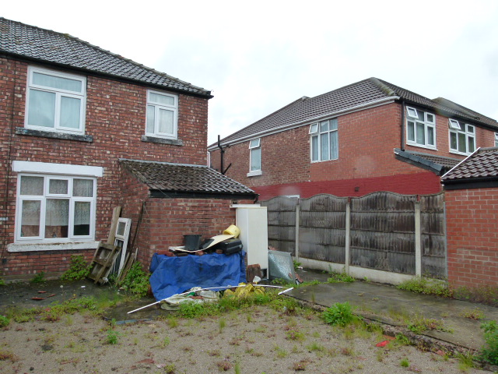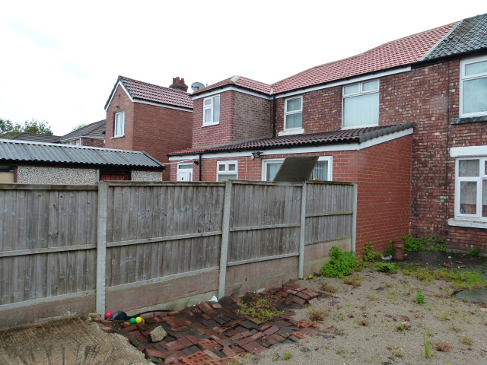
The application site and No.14 Delacourt Road Looking towards No.10 Delacourt Road

Visual amenity
The extensions will have an acceptable visual impact. From the street, the extension appears subservient to the original dwelling. It is sited on the gap on the western side, which is 2 metres wide, with the extension being 1.9 metres wide with a set back at first floor also of 1.9 metres. The extended roof ridge is set down by 598mm. These design measures are adequate to ensure that no terracing will occur should No.14 wish to extend to the boundary in future.

The design follows the aesthetics of the original with a hipped roof, and eaves and window header and cills lined through.

The materials are brick and tile to match the original all of which will enable the extension to assimilate with the original to the benefit of the appearance of the dwelling in the street scene.

The size and scale of the extensions at ground and first floor are within acceptable limits when assessed against saved UDP policy guidelines and current Permitted Development regulations.

Bin storage
As development closes off the gap at the side, the agent has included a bin store in the front garden area, shown on the amended proposed floor plans (No.2 Rev A received on the 10th of June 2021). This is required to be implemented in accordance with the amended drawing prior to the extensions being first occupied to ensure that bins are appropriately managed in the street and that there is no conflict with the retained parking space in the front curtilage.

Parking
The parking space at the front is retained. Although it appears on plan that it is somewhat compromised by the ground floor side extension which is flush with the front elevation, parking was accommodated forward of the front elevation on the site visit for this assessment. The gap is also too narrow to accommodate most modern cars and falls short of the current parking standard dimensions.

Flood risk
As the site lies within Flood Risk Zone 2 which is a low (0.1 -1 % per year) to medium (1 – 3.3% per year) risk of flooding, the applicant was required to submit a Flood Risk Statement which sets out the historic and known risks of flooding from a range of sources, and the measures to mitigate future risks.

The agent submitted a letter which has acknowledged sources of flooding and has stated that the extensions at ground level will be no lower than the existing finished floor levels. This is a requirement in the Environment Agency standing advice reiterated in the guidance from the Flood Risk Management team. Guidance is appended as an Informative on the construction of drainage systems, finished floor levels and registering the property to receive Flood Alerts to mitigate the risks.

Conclusion
The proposal has acceptable impacts on residential and visual amenity, parking and bin storage and therefore complies with saved UDP policy DC1 and policies SP1, DM1 and EN17 and EN19 of the Manchester Core Strategy.

Human Rights Act 1998 considerations
This application needs to be considered against the provisions of the Human Rights Act 1998. Under Article 6, the applicants (and those third parties, including local residents, who have made representations) have a right to a fair hearing and to this end the local planning authority must give full consideration to their comments.

Protocol 1 Article 1, and Article 8 where appropriate, confer(s) a right of respect for a person’s home, other land and business assets. In taking account of all material considerations, including Council policy as set out in the Core Strategy and saved polices of the Unitary Development Plan, the Director of Planning, Building Control & Licensing has concluded that some rights conferred by these articles on the applicant(s)/objector(s)/resident(s) and other occupiers and owners of nearby land that might be affected may be interfered with but that that interference is in accordance with the law and justified by being in the public interest and on the basis of the planning merits of the development proposal. She believes that any restriction on these rights posed by the recommendation given is proportionate to the wider benefits of and that such a decision falls within the margin of discretion afforded to the Council under the Town and Country Planning Acts.

Recommendation: Approve

Article 35 Declaration
The local planning authority in making its decision has had due regard to paragraph 47 of the National Planning Policy Framework as well as the development plan, national planning policy and other material considerations and has approved the application subject to appropriate conditions and for the reasons outlined in the delegated report. The application received no objections on notification and has been approved with appropriate conditions as set out below, in the interests of residential and visual amenity.

Condition(s) to be attached to decision for approval OR Reasons for recommendation to refuse

1) The development must be begun not later than the expiration of three years beginning with the date of this permission.

Reason - Required to be imposed pursuant to Section 91 of the Town and Country Planning Act 1990.

2) The development hereby approved shall be carried out in accordance with the following drawings and documents received on the 9th of April 2021 or as stated:

Application form
Location Plan, Block Plan and Existing Plans and Elevations - Drawing 1
Proposed Plans - Drawing 2 Rev A (Bin store added) received by email on the 10 June 2021
Proposed Elevations - Drawing 3 (Amended labelling) received by email on the 10 June 2021
Flood Risk Letter from I Planning and Architectural Services received on the 19 April 2021

Reason - To ensure that the development is carried out in accordance with the approved plans, pursuant to policies SP1 and DM1 of the Core Strategy.

3) The materials to be used on the external surfaces of the extension hereby permitted shall match those of the existing building in type, size, colour and texture, as stated on the Householder Application Form.

Reason: In order to ensure a satisfactory appearance in the interests of visual amenity in accordance with saved policies DC1 of the Unitary Development Plan for the City of Manchester, SP1 and DM1 of the Manchester Core Strategy and the requirements of the National Planning Policy Framework.

4) The first-floor bathroom window on the extended side elevation shown on drawings 2 and 3, shall be obscure glazed to a specification no less than Level 5 on the Pilkington Glass Scale or such other alternative equivalent and shall remain so in perpetuity.

Reason - To protect the amenity and living conditions of adjacent residential properties from overlooking or perceived overlooking in accordance with policy DM1 of the adopted Core Strategy Development Plan Document for the City of Manchester and saved UDP policy DC1.

5) Prior to first occupation of the development hereby approved, the bin store shown on amended drawing 2 Rev A received by email on the 10 June 2021, shall be implemented in accordance with the approved scheme and shall be so maintained and retained at all times thereafter.

Reason - In the interests of the appearance of the street scene, pursuant to saved policy DC1 of the Unitary Development Plan for the City of Manchester, and policy DM1 of the Manchester Core Strategy.

Informatives

The applicant should design and construct drainage system to prevent the increased risk of flooding, to improve and protect water quality and ensure future maintenance of the surface water drainage system pursuant to policy EN17 of the Core Strategy.

As the proposed development is within Flood Zone 2, floor levels should be set no lower than existing floor levels.

The applicant is encouraged to register the property to receive Flood Alerts in accordance with the Environment Agency Standing Advice. Details can be found at: https://www.gov.uk/sign-up-for-flood-warnings.
Appendix 1 – List of consultees & neighbours notified

MCC Flood Risk Management

10 Delacourt Road, Manchester, M14 6BX
113 Victoria Road, Old Moat, Manchester, M14 6DA
14 Delacourt Road, Manchester, M14 6BX
115 Victoria Road, Old Moat, Manchester, M14 6DA
17 Delacourt Road, Manchester, M14 6BU
15 Delacourt Road, Manchester, M14 6BU
13 Delacourt Road, Manchester, M14 6BU

Appendix 2 – Planning constraints

Article 4 Direction - Removal Of PD Rights Change Of Use From Class C3 To Class C4
Aircraft Safeguarding Zone - Aircraft Safeguarding Zone - All Exceeding 90M
Flood Zones Type 2 (low to medium risk) -
Susceptible to Surf Water Flood (Less) -
Susceptible to Surf Water Flood (Middle) -
Area Team Boundary - Name: SOUTH

