Planning
Growth & Development
Delegated officer report for planning application

Application no. 129485/JO/2021
Date registered valid: 24 February 2021
Proposal: Variation of condition number 2 (Specified Plans) from planning approval reference 127290/FH/2020 to allow the introduction of a first floor external terrace and associated balustrade and minor amendments to the elevations.
Address: 10 Hayescroft Gardens, Manchester, M20 2AA
Ward(s): Didsbury West Ward
Applicant: Mr & Mrs Oliver Johnson 10 Hayescroft Gardens, Manchester, M20 2AA
Agent (if any): Mr Morgan Grennan Jeffrey Bell Architects 3 Cobourg Street, Manchester, M1 3GY
Case officer: David Lawless
Tel: 0161 234 4543
Email: david.lawless@manchester.gov.uk
Recommendation: Approve
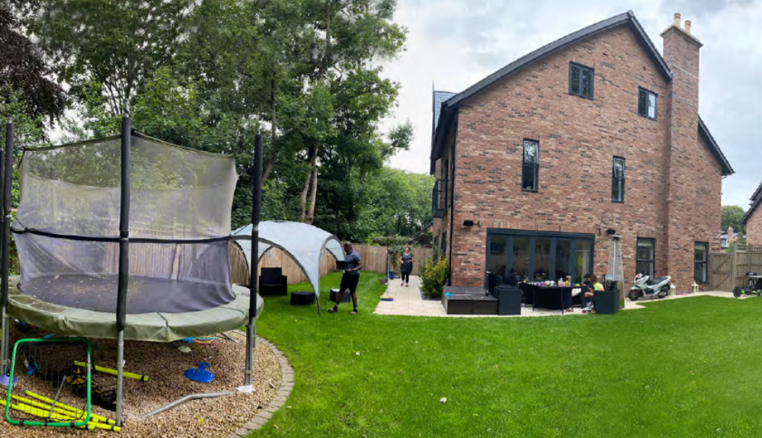
Date of recommendation: 20.4.21

Application details

Type of application: Variation or Removal of Condition

Development type: Householder

Standard consultations:
Printed: 2 March 2021 Expired: 23 March 2021

Neighbour notifications
Printed: 2 March 2021 Expired: 23 March 2021

Site notice
No site notice has been produced

Press advert
No press advert had been published

Departure from Development Plan: No

Environmental Statement: Not required

Description of site/building/area

10 Hayescroft Gardens is a 3 storey detached dwellinghouse situated in small estate off Palatine Road. The estate has been built on the site of a former office block and is enclosed by mature landscaping that is designated as an SBI. To the north and west of the property there are dwellinghouses, while to the south and east lies the SBI. Beyond the SBI stands Ashfield Lodge,
an apartment building also accessed off Palatine Road.

Listed building: no
Conservation area: no
Tree Preservation Order: no

Description of development

The applicants obtained planning permission in September 2020 to erect a single storey rear extension. They are now applying to amend the approved drawings in order to provide a small terraced area on top of the extension with associated balustrading. In addition, amendments are proposed in relation to the type of doors/windows to be installed on the rear and side elevations.

Consultations & Notification Responses

Local Residents – letters have been received from local residents, the points are summarised below:

- The proposed change has the potential to impact on the local wildlife and habitat due to noise and light. The terrace would directly overlook the wetland area / pond where these is a significant range of species, including nesting birds. This habitat provides safety and shelter in a highly populated urban area and any change to this though disturbance would be a detriment to the local ecosystem at a time when many areas like this are under threat.
- Noise and night-time disturbances would also impact neighbouring properties, again to the detriment of the local area.
- This patio will mean that more noise and light will originate above the boundary fence level, and could result in significant additional disturbance if they decide to party on the patio.
If the Council is minded to allow this I would suggest that there should be a requirement to raise the height of the existing fence panels on the boundary between Hayescroft Gardens and Ashfield Lodge.

West Didsbury Residents Association – Object on the grounds that the proposed roof terrace has potential to disturb established patterns of wildlife movement to the detriment of the welfare of the SBI, due to noise and night-time lighting.

Neighbourhood Services (Arbo) – There are no objections from an Arboricultural perspective subject to there being no impact on the protected trees adjacent to this site. The desire to have an additional area to enjoy the outdoors could cause additional pressure to prune the trees to allow more natural light, this would set a precedent for other residents wanting to chip away at the protected woodland.

Policies

The National Planning Policy Framework (February 2019) – The National Planning Policy Framework (NPPF) sets out the Government’s planning policies for England and how these should be applied. It provides a framework within which locally-prepared plans for housing and other development can be produced. Planning law requires that applications for planning permission be determined in accordance with the development plan, i.e. the Core Strategy Development Plan Document and accompanying policies, unless material considerations indicate
otherwise. The NPPF is a material consideration in planning decisions.

Paragraph 11 states that plans and decisions should apply a presumption in favour of sustainable
development which for decision-taking this means:

• approving development proposals that accord with an up-to-date development plan without
delay; or
• where there are no relevant development plan policies, or the policies which are most important for determining the application are out-of-date, granting permission unless:

i. the application of policies in this Framework that protect areas or assets of particular importance provides a clear reason for refusing the development proposed; or
ii. any adverse impacts of doing so would significantly and demonstrably outweigh the benefits, when assessed against the policies in this Framework taken as a whole.

Core Strategy Development Plan Document – The Core Strategy Development Plan Document
2012 -2027 ("the Core Strategy") was adopted by the City Council on 11th July 2012. It is the key
document in Manchester's Local Development Framework. The Core Strategy replaces significant elements of the Unitary Development Plan (UDP) as the document that sets out the long term strategic planning policies for Manchester's future development.

A number of UDP policies have been saved until replaced by further development plan documents to accompany the Core Strategy. Planning applications in Manchester must be decided in accordance with the Core Strategy, saved UDP policies and other Local Development Documents. Relevant policies in the Core Strategy are detailed below:

Policy SP1, Spatial Principles – Development in all parts of the City should make a positive contribution to neighbourhoods of choice including creating well designed places that enhance or
create character and protect and enhance the built and natural environment.

Policy DM1, Development Management – This policy states that all development should have regard to a number of specific issues, the most relevant of which in this instance are:

• Appropriate siting, layout, scale, form, massing, materials and detail.
• Impact on the surrounding areas in terms of the design, scale and appearance of the proposed development. Development should have regard to the character of the surrounding area.
• Effects on amenity, including privacy, light, noise, vibration, air quality, odours, litter, vermin, birds, road safety and traffic generation. This could also include proposals which would be sensitive to existing environmental conditions, such as noise.
• Accessibility: buildings and neighbourhoods fully accessible to disabled people, access to new development by sustainable transport modes.
• Community safety and crime prevention.
• Adequacy of internal accommodation and external amenity space.
• Refuse storage and collection.
• Vehicular access and car parking.
• Effects relating to biodiversity and landscape.
• Green Infrastructure including open space, both public and private.
• Flood risk and drainage.
• Subject to scheme viability, developers will be required to demonstrate that new development incorporates sustainable construction techniques

Issues

Principle of the Proposal – The principle of the development is considered acceptable. Notwithstanding this, consideration must be given to the potential impact upon existing levels of
residential and visual amenity enjoyed within the vicinity of the site and upon the habitat of the nearby badgers.

Design – The contemporary design of the proposed extension is considered acceptable and will complement the existing property. The addition of the small terraced area and balustrading and amendments to the type of doors used in the extension will not detract from the overall design of the extension (original approval on the left):

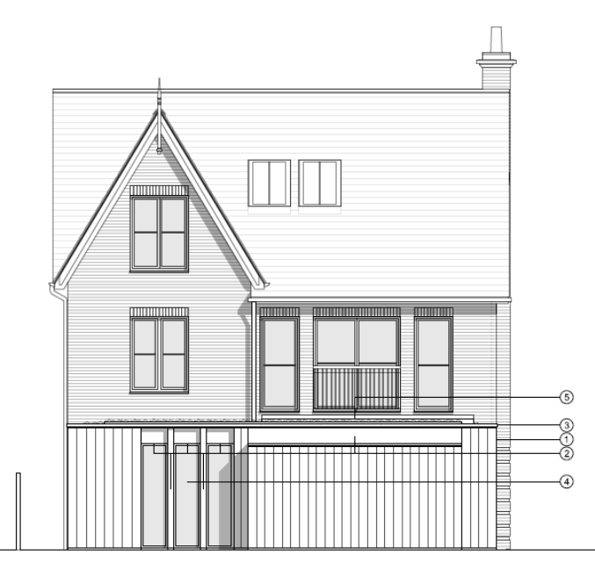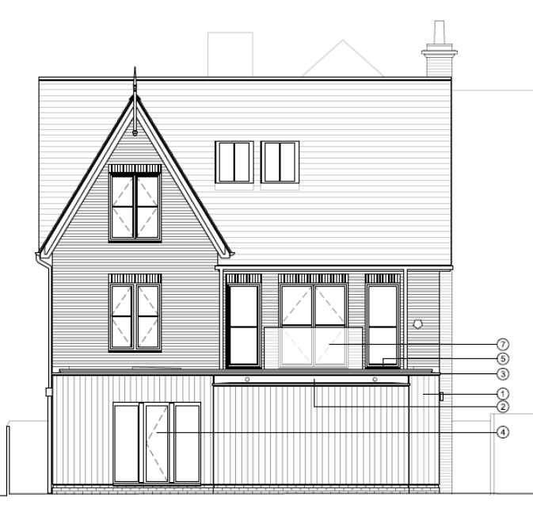

Visual Amenity – The proposed extension will not have a detrimental impact upon the levels of residential and visual amenity currently enjoyed within the vicinity of the site.

Residential Amenity – The addition of the terrace will have not have a detrimental impact upon the existing levels of residential amenity enjoyed within the vicinity of the site. It will be sited 6.5 metres from the common boundary with no. 11 Hayescroft Gardens, is set in from the edge of the roof and so overlooking is not considered to be a significant concern. It is considerably further away from Ashfield Lodge and there is also a band of landscaping between the two properties in question.

In addition, it is highly unlikely that the terraced area would give rise to unacceptable levels of noise and disturbance given its small size so the concerns that the proposal would increase the instances of noise and disturbance is not supported.

Trees – There are no trees within the site. There are trees beyond the rear fence line, located in
the SBI corridor that allows badgers to travel between the western and eastern halves of the SBI.
As the property is built on an elevated section with a retaining wall it is not anticipated that these
trees will be impacted upon. Notwithstanding this, it is felt prudent to attach a condition to any consent granted which requires the construction work to be undertaken in accordance with the previously approved arboricultural method statement.

Ecological Impacts – The location of the badger setts is well documented, and their presence led to the creation of the landscaped corridor at the rear of this and the adjoining properties. The applicant has previously submitted a survey of the setts and their usage and this has been assessed by GMEU. They raised no objections to the proposal subject to a construction method statement being submitted which details how the extension would be built and the impact on badgers mitigated against. Once this has been submitted for discharge the advice of GMEU will be sought again. Given this it is considered that any potential impact upon the badgers can be successfully mitigated against.

Pedestrian and Highway Safety – The proposal will not have a detrimental impact upon the
levels of pedestrian and highway safety enjoyed within the vicinity of the site.

Car Parking – Sufficient off-street car parking will remain for the occupants of the property.

Human Rights Act 1998 considerations

This application needs to be considered against the provisions of the Human Rights Act 1998. Under Article 6, the applicants (and those third parties, including local residents, who have made representations) have a right to a fair hearing and to this end the local planning authority must give full consideration to their comments.

Protocol 1 Article 1, and Article 8 where appropriate, confer(s) a right of respect for a person’s home, other land and business assets. In taking account of all material considerations, including Council policy as set out in the Core Strategy and saved polices of the Unitary Development Plan, the Director of Planning, Building Control & Licensing has concluded that some rights conferred by these articles on the applicant(s)/objector(s)/resident(s) and other occupiers and owners of nearby land that might be affected may be interfered with but that that interference is in accordance with the law and justified by being in the public interest and on the basis of the planning merits of the development proposal. She believes that any restriction on these rights posed by the recommendation given is proportionate to the wider benefits of and that such a decision falls within the margin of discretion afforded to the Council under the Town and Country Planning Acts.

Recommendation: Approve

Article 35 Declaration

Officers have worked with the applicant in a positive and proactive manner to resolve any matters arising in relation to dealing with the planning application.

Condition(s) to be attached to decision for approval OR Reasons for recommendation to refuse

1) The development must be begun not later than the expiration of three years beginning with the date of planning permission reference 127290/FH/2020, that date being 22 September 2020.

Reason - Required to be imposed pursuant to Section 91 of the Town and Country Planning Act 1990.

2) The development hereby approved shall be carried out in accordance with the following drawings and documents:

a) Drawing nos. AL (05) 201 to 208, stamped as received on 22 February 2021.

Reason - To ensure that the development is carried out in accordance with the approved plans. Pursuant to policies SP1 and DM1 of the Core Strategy.

3) Above-ground construction works shall not commence until samples and specifications of all materials, including window frames, to be used in the external elevations have been submitted to and approved in writing by the City Council as local planning authority. Thereafter the development shall be carried out in accordance with those details.

Reason - To ensure that the appearance of the development is acceptable to the City Council as local planning authority in the interests of the visual amenity of the area within which the site is located, as specified in policies SP1 and DM1 of the Manchester Core Strategy (2012).

4) All work within the site should be undertaken in accordance with the Arboricultural Impact Assessment and Method Statement (Rob Longley Tree Consultancy, Ref: RL/RP150519AIA&AMS).

Reason - In order avoid damage to trees/shrubs adjacent to and within the site which are of important amenity value to the area and in order to protect the character of the area, in accordance with policies EN9 and EN15 of the Core Strategy.

5) Prior to the commencement of development a Construction Method Statement, detailing the measures to be taken during the course of any construction works to avoid any disturbance to badgers, shall be submitted to and approved by the City Council as local planning authority. The development shall then be undertaken in accordance with the approved Construction Method Statement.

Reason - To ensure the protection of habitat of species that are protected under the Wildlife and Countryside Act 1981 (as amended) in order to comply with policy EN15 of the Manchester Core Strategy.

Appendix 1 – List of consultees & neighbours notified

High Speed Two (HS2) Limited
Neighbourhood Team Leader (Arboriculture)
Greater Manchester Ecology Unit
West Didsbury Residents Association

22 Ashfield Lodge, 229 Palatine Road, Manchester, M20 2UD
17 Ashfield Lodge, 229 Palatine Road, Manchester, M20 2UD
19 Ashfield Lodge, 229 Palatine Road, Manchester, M20 2UD
20 Ashfield Lodge, 229 Palatine Road, Manchester, M20 2UD
24 Ashfield Lodge, 229 Palatine Road, Manchester, M20 2UD
25 Ashfield Lodge, 229 Palatine Road, Manchester, M20 2UD
27 Ashfield Lodge, 229 Palatine Road, Manchester, M20 2UD
16 Ashfield Lodge, 229 Palatine Road, Manchester, M20 2UD
29 Ashfield Lodge, 229 Palatine Road, Manchester, M20 2UD
30 Ashfield Lodge, 229 Palatine Road, Manchester, M20 2UD
18 Ashfield Lodge, 229 Palatine Road, Manchester, M20 2UD
21 Ashfield Lodge, 229 Palatine Road, Manchester, M20 2UD
23 Ashfield Lodge, 229 Palatine Road, Manchester, M20 2UD
26 Ashfield Lodge, 229 Palatine Road, Manchester, M20 2UD
28 Ashfield Lodge, 229 Palatine Road, Manchester, M20 2UD
11 Hayescroft Gardens, Manchester, M20 2AA
9 Hayescroft Gardens, Manchester, M20 2AA

Appendix 2 – Planning constraints

Article 4 Direction - Removal Of PD Rights Change Of Use From Class C3 To Class C4
Aircraft Safeguarding Zone - Aircraft Safeguarding Zone - All Exceeding 90M
Area Team Boundary - Name: SOUTH

