Planning
Growth & Development
Delegated officer report for planning application

Application no. 129798/FH/2021
Date registered valid: 29 March 2021
Proposal: Erection of a part single/part 2 storey rear extension to form additional living accommodation
Address: 334 Wilbraham Road, Manchester, M21 0UX
Ward(s): Chorlton Park Ward
Applicant: Mr Ali Mohamed Salim 334 Wilbraham Road, Manchester, M21 0UX
Agent (if any): Mr Yasin Ahmed Y A Architectural Servies Unity House, Fletcher Street, Bolton, BL3 6NE
Case officer: Tracie Simpson
Tel: 0161 234 4537
Email: tracie.simpson@manchester.gov.uk
Recommendation: Approve
Date of recommendation: 16th June 2021

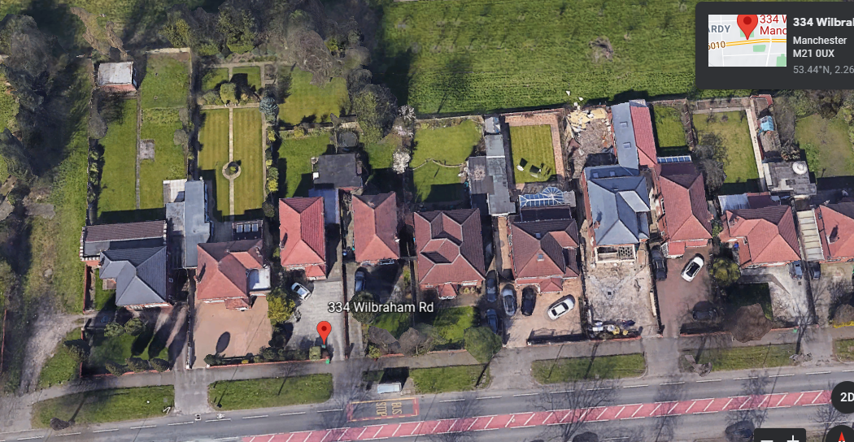
Application details

Type of application: Full Householder Application
Development type: Householder
Date of site visit:
Standard consultations: No consultations have been printed and sent.
Neighbour notifications Printed: 31 March 2021 Expired: 21 April 2021
Site notice No site notice has been produced
Press advert No press advert had been published
Departure from Development Plan: No
Environmental Statement: Not required

Description of site/building

The proposal site contains a two storey detached dwelling within the Chorlton Park Ward area of Manchester. The property is constructed externally from red brick, concrete roof tiles and has white UPVC windows and doors. The proposal site has a small front garden with low boundary wall treatment with hedging access along the sides leading into the rear garden. Off road car parking is available at the front. The property benefits from a front porch and detached garage to the rear.

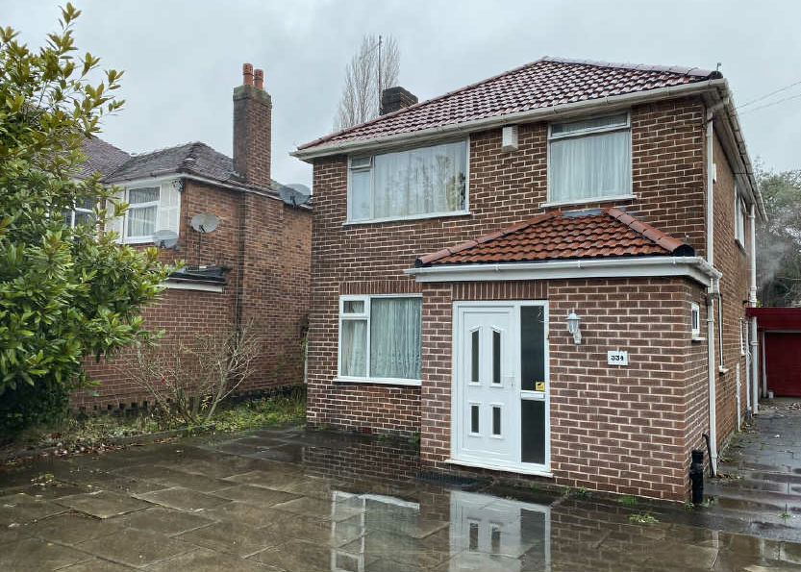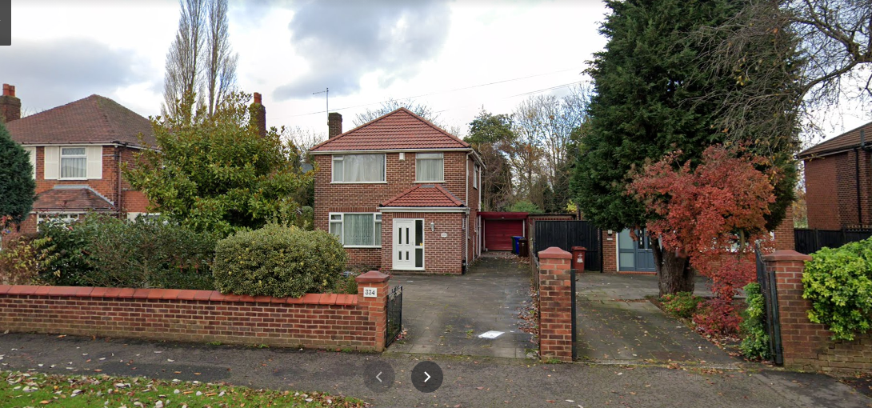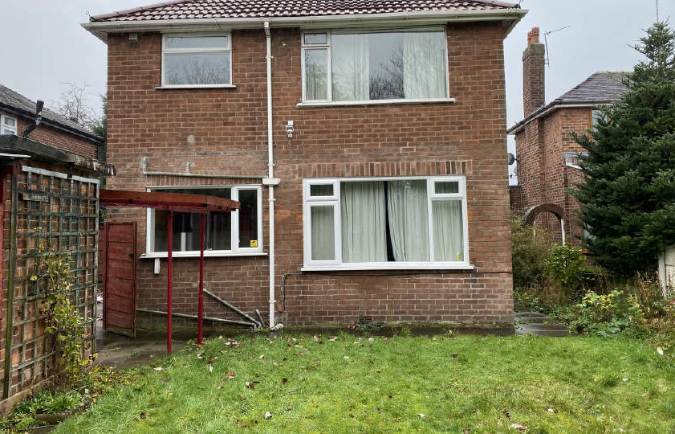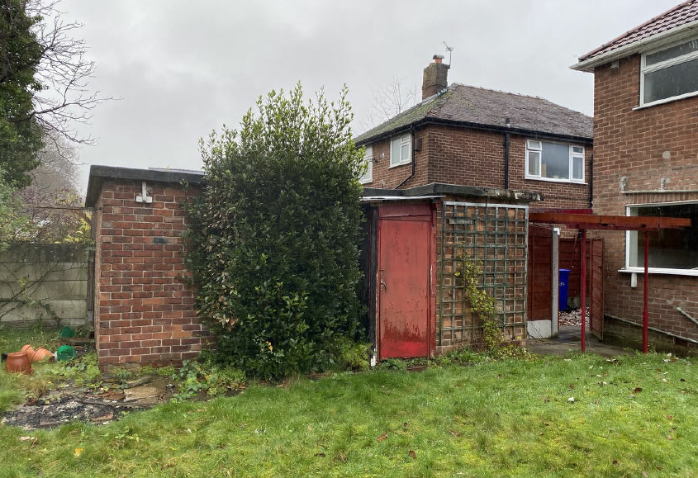

Listed building: Not applicable
Conservation area: Not applicable
Tree Preservation Order: Not applicable

Description of area

The area is predominantly residential in nature

Description of development

The applicant is seeking planning consent for the erection of a part single/part 2 storey rear extension to form additional living accommodation.

Consultations & Notification Responses

Local residents/public opinion - There have been no comments/representations received as a result of this proposal.

Policy and Issues

The following policies are considered relevant in the consideration of this application.

The following policies are considered relevant in the consideration of this application.

o Unitary Development Plan (UDP) - The UDP has been superseded by the Core Strategy Development Plan.
o Policy DC1 for Residential Extensions is still considered of relevance, in particular policy DC1.5 - The Council will consider on their merits exemptions to the above policies in the case of applications from disabled people who may require particular adaptations to their homes.
o The Manchester Core Strategy Development Plan Document 2012-2027 ("the Core Strategy") was adopted by the City Council on 11th July 2012.
o Policy DM 1 - Development Management
o Policy SP1 - Spatial Principles
o Policy EN1 - Design Principles
o Policy EN19 Waste
o The National Planning Policy Framework (NPPF)

For reasons to be outlined below, it is considered the proposal does not accord with the principles of this policy document.

Principle

The principle of allowing residents to extend their homes to provide enlarged or improved accommodation is generally acceptable provided that there is no overriding, undue impact upon either the character of the property or upon the residential and visual amenity of nearby residential occupiers.

In this instance the principle of the proposal is considered acceptable and it is not believed that there are any factors of sufficient weight in amenity terms that would warrant refusal of the application.

On balance, the proposed extension is deemed to accord with saved policy DC1 of the UDP and policies DM1 and SP1 of the Manchester Core Strategy.

History

There has been one previous planning application relating to this site as follows:

087782/FH/2008/S1 - Erection of a single storey side extension to form additional living accommodation. This application was approved 30th October 2008

Residential Amenity

Following raised concerns by the City Council, the applicant amended the plans providing a larger gap to the shared boundary with the adjacent property no. 336 Wilbraham Road which is considered to be an acceptable change to the original submission.

The applicant proposes to erect a part single, part two storey rear extension to form additional living accommodation. The property is along Wilbraham road bounded by similar properties varying in style which have undergone changes by means of extensions both single and two storeys, however, have retained the character of the area.

Ground Floor

The ground floor element of the proposal would be in line with the side walls of the house projecting 5.2 metres approximately off the rear wall of the house to a width across the rear wall of 6.784 metres. The roof would be a dual pitch roof with a window and sliding doors on the rear elevation and a door on the side elevation.

First Floor

The first floor element of the proposal has been amended to provide a 1.619 metre gap to the shared boundary with no. 334 Wilbraham Road and would extend across the rear up to the side wall of the property on the opposite side. Projection of the rear wall would be 4.050 metres set down slightly from the existing roof ridge of the house. The roof would be hipped to reflect the existing style roof of the property. Two windows are proposed overlooking the rear garden with no windows proposed on the sides.

There is an existing garage/outbuilding in the rear garden alongside the shared boundary with no. 338 Wilbraham Road. The garage which although would be situated close to the rear extension of the property would not have access into the garage from the extension. Elevational alterations do not form part of this proposal however, the applicant is removing a door to original side wall of the property and reducing the size of an existing side window.

Overall, the impression of subservience is achieved by the height of the proposed roof being set down from the height of the existing roof. Given the height, projection and relationship to adjacent properties, it is considered that the proportions of the extensions are acceptable. The footprint is not considered to create a bulky or disproportionate scale addition to the property.

In terms of residential amenity, it is not considered that there will be any significant impact and the proposed development therefore accords with Core Strategy Policy DM1 and saved policy DC1 of the UDP.

Siting, scale and massing

The size and footprint of the proposed extension is comparable in size to many others found in the area and is not believed to provide an overbearing impact upon the residential amenities of surrounding properties. The appearance is acceptable and its impact upon visual amenity is considered negligible.

It is therefore considered that the scale and mass of the proposed extensions are satisfactory and are considered to accord with the principles for residential extensions set out in saved UDP policy DC1, DM1 and EN1 of the Core Strategy.

Design

The design of the proposal would be in keeping with the existing and surrounding properties in the area. In terms of the proposed materials it is intended to use matching bricks and tiles as specified in the application form. The design of the extension has been tailored to fit the shape of the existing property/plot and respect the relationship with the neighbouring property at the side and rear and is considered acceptable and detailed as what is normally expected of such a structure.

On balance it is considered that the design and appearance of the proposed development accords with Core Strategy Policies DM1 and EN1 and in general the design is considered acceptable.

Disabled access

Not applicable

Refuse Bins

Bins storage is no affected by this proposal as the bins can still be stored at the rear of the property and therefore the storage of refuse bins accords with policy EN19 of the Core Strategy.

Parking

Off street car parking space would be retained to the site and therefore it is considered that car parking arrangements are not affected by this proposal.

Conclusion

The proposal would not be visible from the public highway and therefore would not be a feature within the street scene, however, the character of the area is still retained. The proposal has been sited and designed to ensure that it is subservient to the original dwellinghouse and the proposal is considered acceptable in this location, in terms of design, scale and massing, allowing the occupiers to adapt their home to meet their needs, without unduly detrimentally affecting the amenities of the occupiers of surrounding properties, or the character and appearance of the surrounding street scene, and there are no material considerations of sufficient weight to indicate otherwise.

Human Rights Act 1998 considerations

This application needs to be considered against the provisions of the Human Rights Act 1998. Under Article 6, the applicants (and those third parties, including local residents, who have made representations) have a right to a fair hearing and to this end the local planning authority must give full consideration to their comments.

Protocol 1 Article 1, and Article 8 where appropriate, confer(s) a right of respect for a person’s home, other land and business assets. In taking account of all material considerations, including Council policy as set out in the Core Strategy and saved polices of the Unitary Development Plan, the Director of Planning, Building Control & Licensing has concluded that some rights conferred by these articles on the applicant(s)/objector(s)/resident(s) and other occupiers and owners of nearby land that might be affected may be interfered with but that that interference is in accordance with the law and justified by being in the public interest and on the basis of the planning merits of the development proposal. She believes that any restriction on these rights posed by the recommendation given is proportionate to the wider benefits of and that such a decision falls within the margin of discretion afforded to the Council under the Town and Country Planning Acts.

Recommendation: Approve

Article 35 Declaration

Positive and proactive working Officers have worked with the applicant in a positive and proactive manner based on seeking solutions to problems arising in relation to dealing with the planning application. The application has been determined in a timely manner and in accordance with the policies within the Development Plan.

Condition(s) to be attached to decision for approval OR Reasons for recommendation to refuse

1) The development must be begun not later than the expiration of three years beginning with the date of this permission.

Reason - Required to be imposed pursuant to Section 91 of the Town and Country Planning Act 1990.

2) The development hereby approved shall be carried out in accordance with the following drawings and documents:

Received on 10th June 2021 numbered P01A Existing Floor Plans and Elevations and Proposed Elevations

Received on 10th June 2021 numbered P02A Proposed Ground and First Floor Plan

Received on 10th June 2021 numbered P03A Proposed Site Plan

Reason - To ensure that the development is carried out in accordance with the approved plans. Pursuant to policies SP1 and DM1 of the Core Strategy.

3) The materials to be used on the external surfaces hereby permitted shall match those as specified on the application form/drawings in type, size, colour and texture.

Reason - To ensure the appearance of the building to be extended is not adversely affected by the materials to be used in the construction of the structure, pursuant to policy DM1 of the Manchester Core Strategy.

4) Notwithstanding the provisions of the Town and Country Planning (General Permitted Development) Order 2015, (or any order revoking and re-enacting that Order with or without modification), no additional openings/windows/doors shall be inserted within the side elevation of the extension hereby approved, unless Planning Permission is specifically granted.

Reason - In the interests of the amenities of the occupiers of neighbouring dwellinghouses, pursuant to saved policy DC1 of the adopted Unitary Development Plan for the City of Manchester, and policy DM1 of Manchester's Core Strategy.

Appendix 1 – List of consultees & neighbours notified

332 Wilbraham Road, Manchester, M21 0UX
336 Wilbraham Road, Manchester, M21 0UX

Appendix 2 – Planning constraints

Article 4 Direction - Removal Of PD Rights Change Of Use From Class C3 To Class C4
Aircraft Safeguarding Zone - Aircraft Safeguarding Zone - All Exceeding 90M
Area Team Boundary - Name: SOUTH

