CITYLABS 2.0 – WASTE MANAGEMENT AND SERVICING STRATEGY
DATE : 20.05.21
Rev.0

1.1 Project Introduction

The planning application for Citylabs 2.0 was granted planning permission in December 2016 (MCC planning ref.114882/FO/2016).

1.0 Purpose of the Report

This Waste Management and servicing Strategy has been prepared to discharge Conditions 15, 19, and 28 attached to the Citylabs 2.0 Development. For clarity, the precise wording of the conditions is provided below:

15 - Prior to first occupation of the development (or phase thereof), details of how 24 hour management of the site in particular in relation to servicing and refuse (storage and removal); shall be submitted to and agreed in writing by the City Council as Local Planning Authority. The approved strategy shall remain in operation in perpetuity.

19 - Before occupation of the development (or phase thereof) a scheme for deliveries, servicing and collections, including waste collections must be submitted to and approved in writing by the City Council as Local Planning Authority. Unless otherwise agreed in writing by the Local Planning Authority deliveries, servicing and collections, including waste collections shall not take place outside the following hours:

07:30 to 20:00 Monday to Saturday
10:00 to 18:00 Sundays and Bank Holidays

28 - The building (or phase thereof) hereby approved shall not be occupied until a scheme for the storage (including segregated waste recycling) and disposal of refuse for the development has been submitted to and approved in writing by the City Council as local planning authority. The details of the approved scheme shall be implemented as part of the development and shall remain in situ whilst the use or development is in operation.

Structure of the Report
Following on from this introduction, Section 2 of this report considers the waste management strategy which details access arrangements and frequency of use for refuse vehicles. Section 3 then considers the access arrangements for delivery vehicles.

2.0 Waste Management Strategy

2.1 Introduction

The Building is being occupied by a single customer Qiagen, who provide technologies for molecular diagnostics, applied testing, academic and pharmaceutical research. The occupancy is a mixture of office and lab space, with meeting rooms, training spaces and staff facilities.

Waste management will be controlled by the Qiagen site management team. Qiagen will place contracts with a private waste contractor (Bagnall & Morris) to collect the waste, including specialist waste collections for clinical and hazardous waste.

The Qiagen site team will be responsible for day to day management of the site, supported by the Citylabs 2.0 limited Management team.

Details of the various waste streams that will be generated on site as follows:

- General waste
- Cardboard waste
- Clinical waste – (waste that has the potential to cause disease, including the following - discarded sharps; human tissue waste; laboratory waste)
- Food waste
- WEEE
- Hazardous waste – Analytical instrument chemical waste and redundant or out of date laboratory chemicals - liquid and solid.

2.2 Internal Arrangements

The occupiers will have bins and bin stores within the building. There will be bins for general refuse, paper/card, co-mingled recyclables (glass/metal/plastic) and organic waste located within the office and lab areas across all floors.

The waste will be transferred from each office and lab area to the GF bin store areas by the building staff, or their cleaner under their direction.

On the Ground floor there are 2 areas for waste collection and storage, the main bin store and the liquid waste store.

The main bin store will contain waste containers as follows:

- General waste – 5 x 1100L
- Cardboard waste – 3 x 1100L
- Clinical waste – 2 x 1100L
- Food waste – 1 x 240L
- WEEE – Stored in bin store area for collection on ad-hoc as required basis

The liquid waste store will contain the hazardous waste.

2.3 Collections

The transfer route from the bin store areas to bring the bins out to the external loading bay area ready for collection is shown in fig 1.1 below. The collection and movement of waste will be managed by the occupier and they may then employ cleaners or use the waste collection company operatives to transfer the waste for collection.

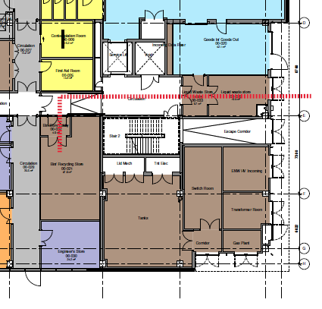
Figure 1.1 – Route from internal bin store to rear external loading bay area

The occupier on-site management team will coordinate the waste collection enabling economies of scale and to reduce the number of individual vehicles entering the site.

Assuming that there is coordination of waste collection, it is estimated that the following number of waste collection vehicles would serve Citylabs 2.0:

- General waste – 2 x weekly
- Cardboard waste – 2 x weekly
- Clinical waste - weekly
- Food waste – weekly (coordinated with the general waste)
- WEEE – To be collected on ad hoc as required basis
- Hazardous waste - To be collected on ad hoc as required basis

Refuse vehicles would enter the external loading bay area from Hathersage road, and park in the loading bay area adjacent to the GF bin store area. Vehicles will leave the site, through the security bollards, and back onto Hathersage Road. The refuse vehicle swept path is shown in fig.1.2.

All waste collections shall be strictly in accordance with Conditions 19 and will not take place outside the following hours:

• 07:30 to 20:00 Monday to Saturday; and
• 10:00 to 18:00 Sundays and Bank Holidays.

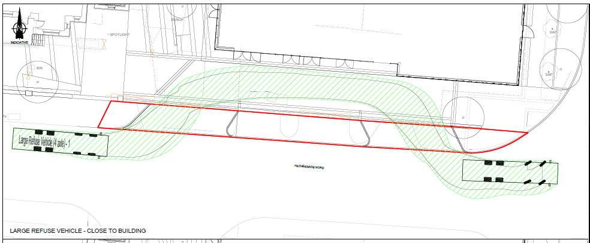

Figure 1.2 – Refuse vehicle swept path entry and exit from external loading bay onto Hathersage Road

3.0 Servicing Strategy

3.1 Introduction

All deliveries and collections from the site will be made from the goods in/ goods out room located on the GF, which has level access to the external loading bay area. This area is accessed via a roller shutter screen with side pedestrian pass door, and an external intercom unit linked to the on-site management office.

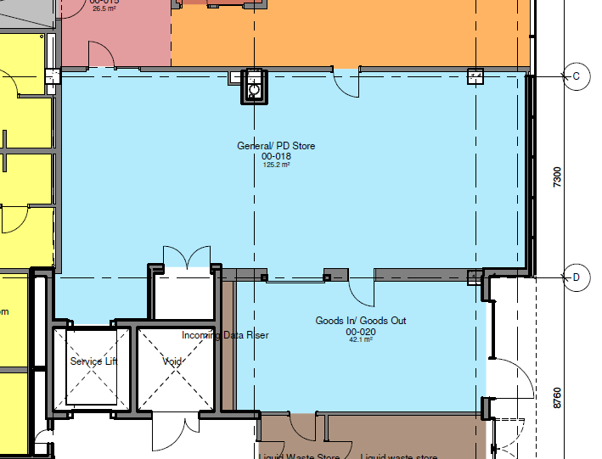

Figure 1.3 – GF Goods in/ out and adjacent store room

Deliveries and goods out will be processed in this area, then stored in the adjacent internal store room.

Vehicles will enter and exit the external goods area following the same route as the refuse vehicle’s.

All deliveries will be managed and coordinated by the on site management team to prevent congestion in the external loading bay area. The Building will be manned to accept deliveries between 8:00 and 17:00 Monday to Friday.

This is in line with Conditions 19 which states that deliveries and collections will not take place outside the following hours:

• 07:30 to 20:00 Monday to Saturday; and
• 10:00 to 18:00 Sundays and Bank Holidays.

