Contract No: MPDN/01 |  | Technical Submittal Sheet
Contract Name: Monkey Puzzle, Northenden.

Technical Submittal Name: |  |  | Bin Store |  |  |  | Date: |  |  | 14.09.21
To: |  |  | Client / MP Day nurseries |  |  |  | Issued By:
From: |  |  |  |  |  |  | Signed:
Lead Time:
Response Required by:
Technical Submittal Description: |  |  | Treated timber quad bin store
Technical Submittal as per Specification? |  |  | Yes or No? |  | No spec specified.
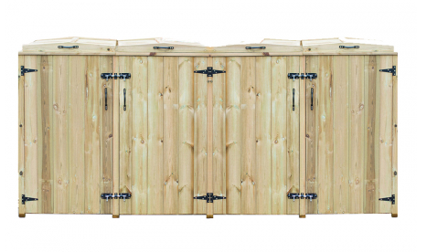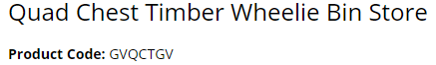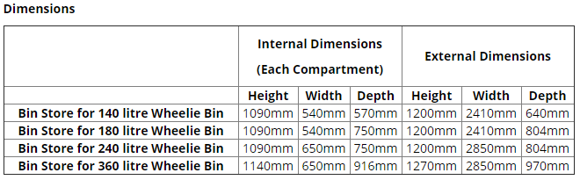

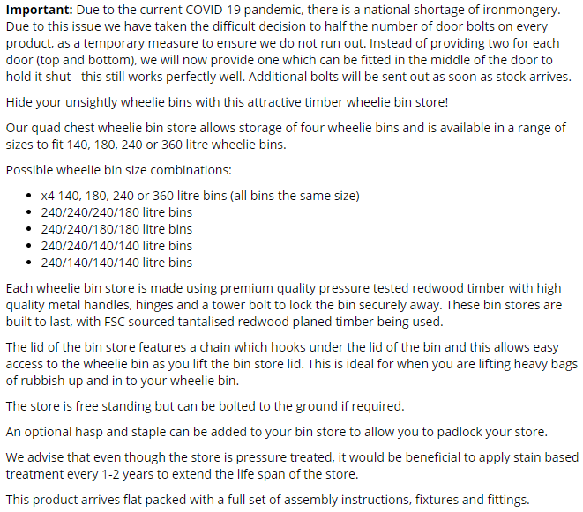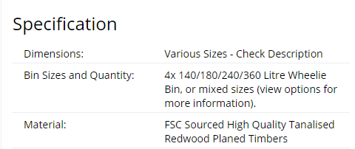

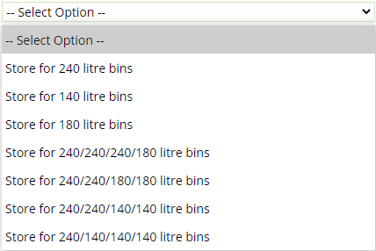

Response | A  Approved for Construction |  |  | B  Approved with comments incorporated |  |  |  |  | C  Rejected / Not approved for construction
Comments:

Revision Comments:
Name |  |  |  |  |  | Signed
Date |  |  |  |  |  | Copies

