Refuse Access Strategy.

In support of the full planning application for:
62 Burton Road, Manchester, M20 3EB

APPLICATION REFRENCE: 132446/OO/2021

Erection of a two storey side and single storey rear extension to form enlarged ground floor retail unit (use class E) and creation of an additional 1 no. first floor two bedroom self contained flat.
On behalf of Mr. Abbas Mohammed
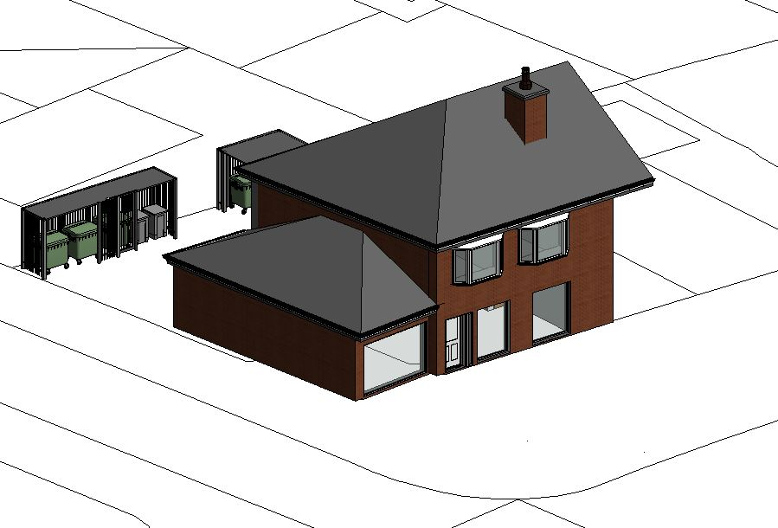

The following refuse strategy has been developed in line with current Manchester
City Councils waste management strategy.

Provision:

General Waste (twice weekly collection)
500 litres commingled waste – glass/cans/plastic (domestic)
500 litres refuse waste (domestic)
500 litres commingled waste – glass/cans/plastic (commercial)
500 litres refuse waste (commercial)

Recycling (2 commodities on 2 weekly schedule)
500 litre paper waste (domestic)
500 litre paper waste (commercial)

Bio waste (food) (collected weekly)
2 green wheeled bins (domestic)
2 green wheeled bins (commercial)

All bins will be removed to kerbside for collection weekly by the landlord.

Dimension:

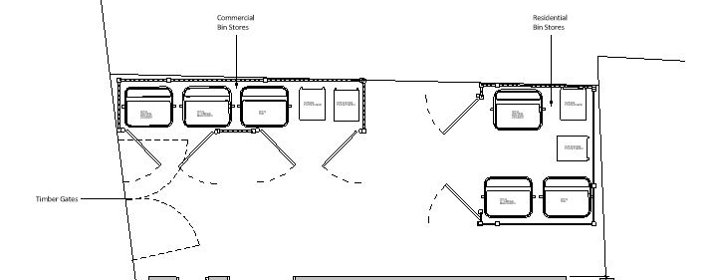
- All container sizes on plan. Typical layout

If required additional recycling facilities can be provided at the rear side of the proposal.

