Photographic evidence of storm water pipes building C2
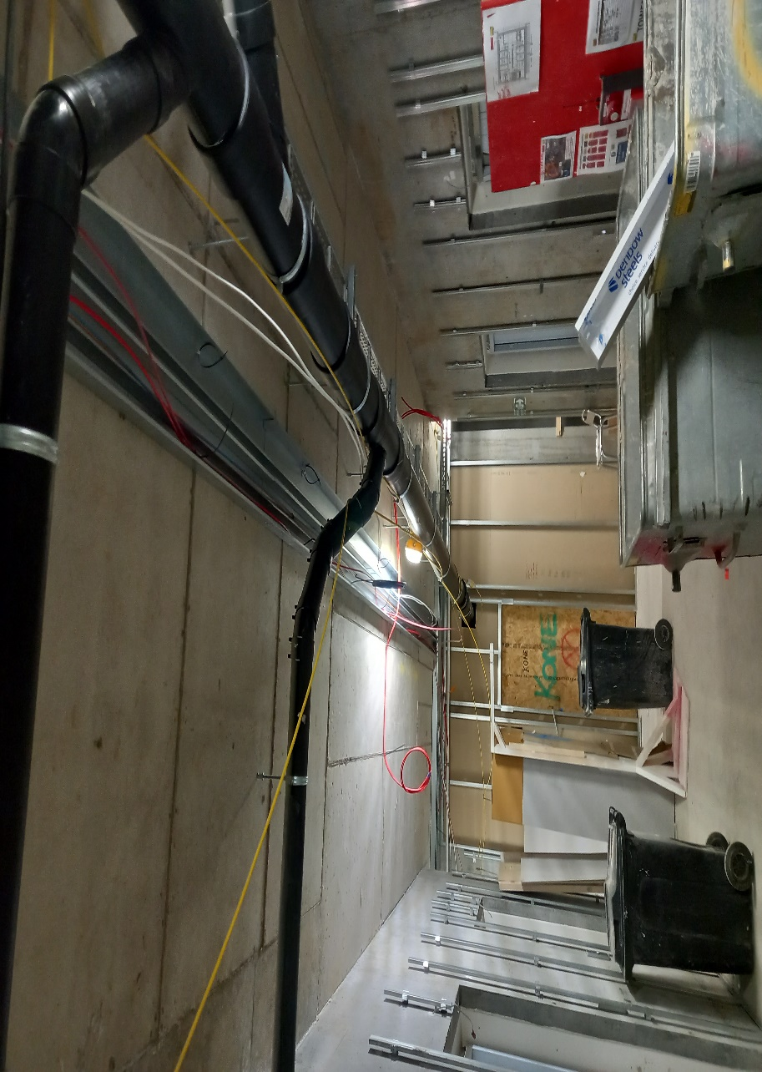 |  | 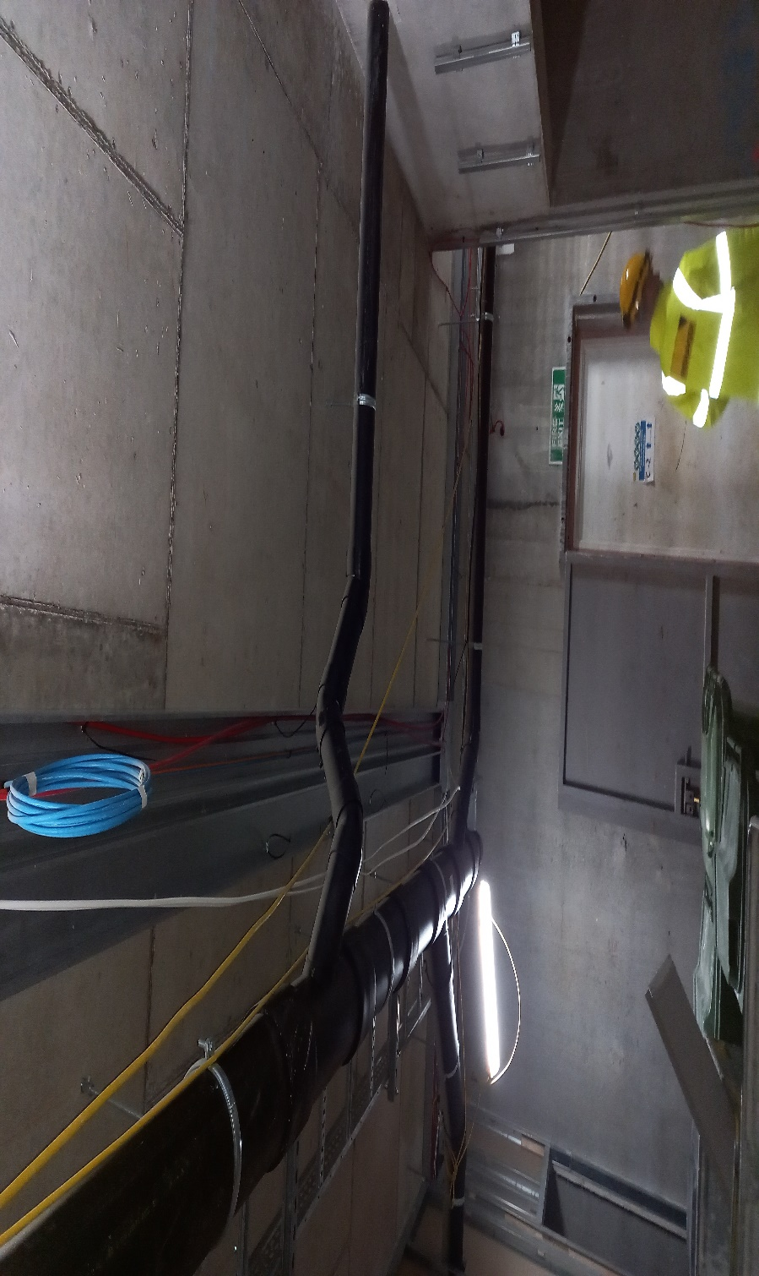
Photo 1 – Storm water pipe C2 B1 lift lobby |  | Photo 2 – Storm Water pipe C2 B1 lift lobby

 | 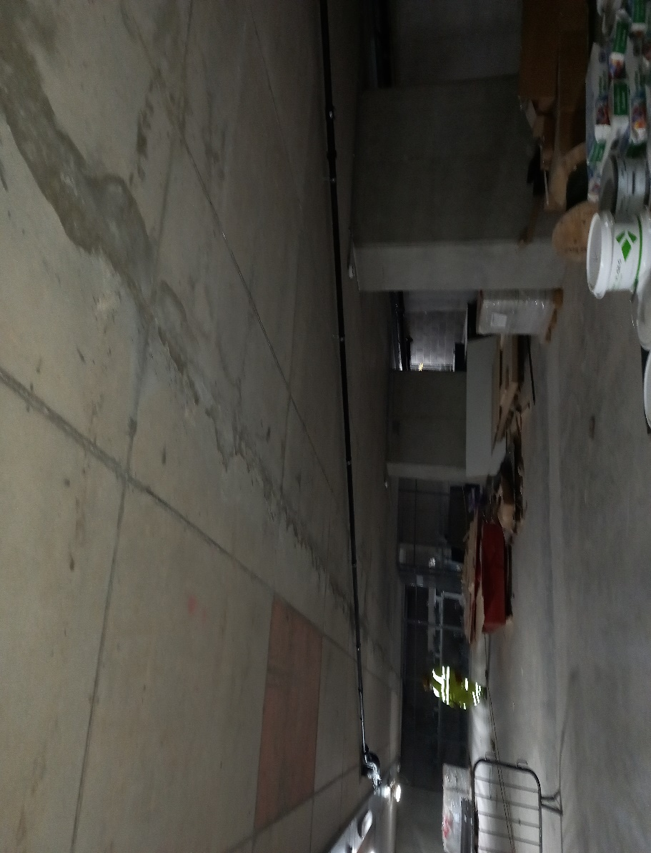 | 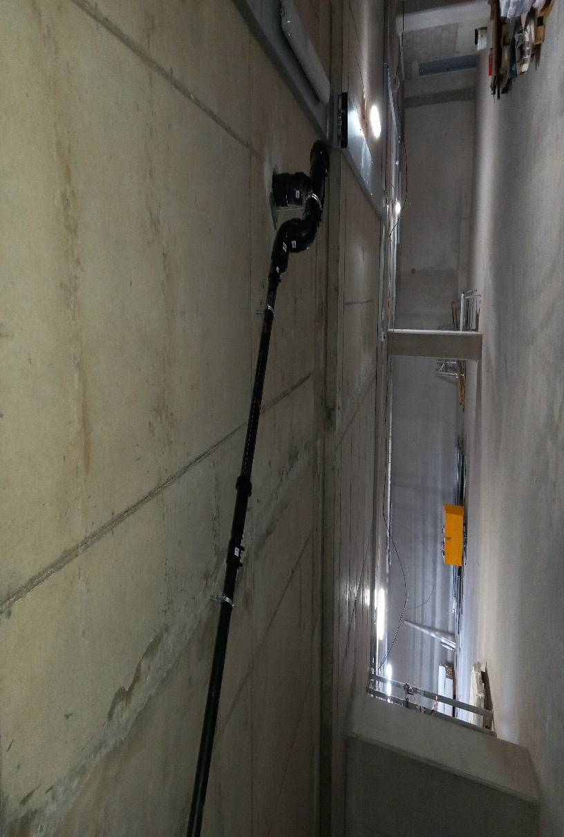
 | Photo 3 – Storm Water pipe C2 B1 carpark below west elevation | Photo 4 – Storm water pipe C2 B1 carpark below west elevation

 | 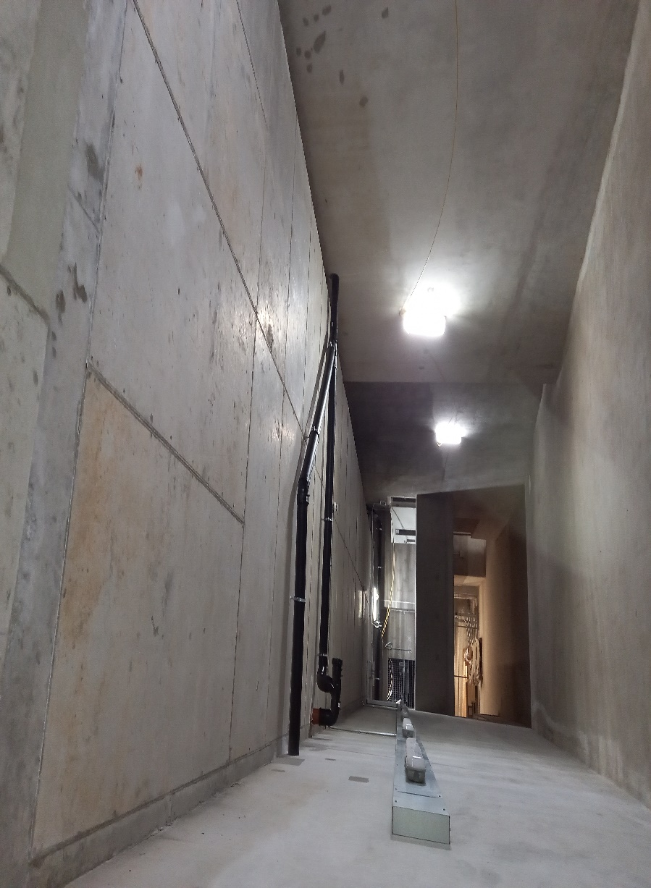 | 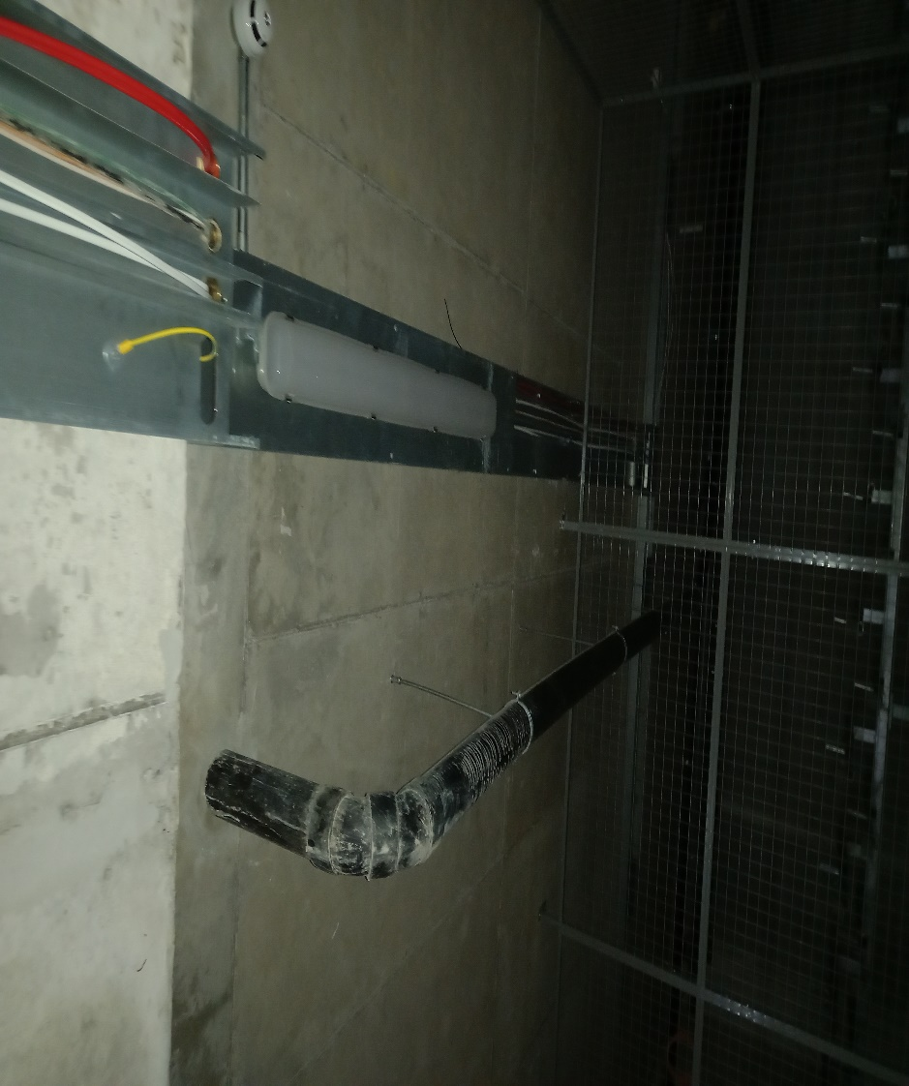
 | Photo 5 – Storm Water pipe C2 B1 – B2 Down ramp | Photo 6 – Storm water pipe C2 B1 Cycle stores below townhouses
 | 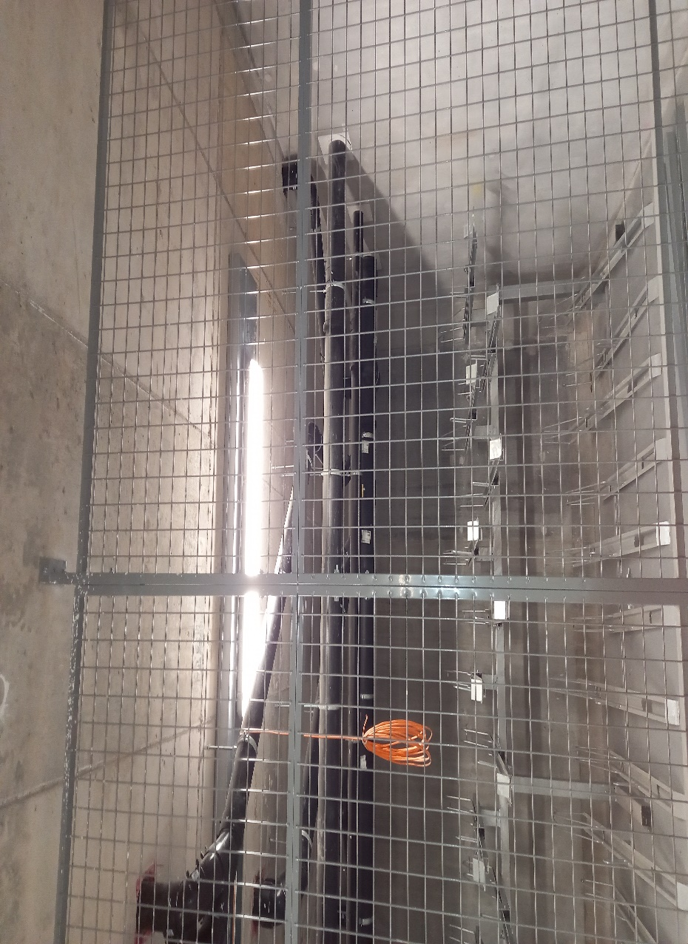 | 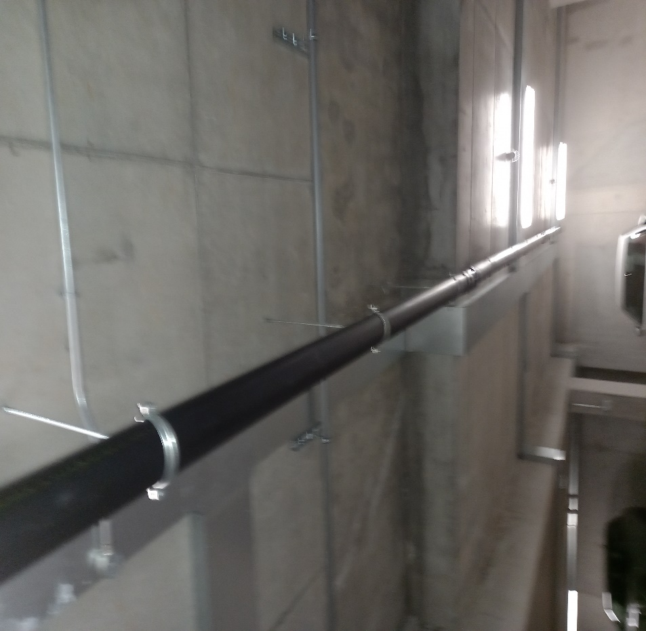
 | Photo 7 – Storm Water pipe C2 B1 cycle stores below townhouses | Photo 8 – Storm Water pipe B1 Carpark under concierge

